Developing an information-theoretically secure cryptographic scheme: Overcoming the practical limitations of the one-time pad cipher using quantum computing

**Webb Rye**

17th April 2024

**Abstract**

With the security of current cryptographic standards being thrown into question with the advancement of quantum computing, new methods of maintaining secrecy in digital communications need to be found.

The focus of this project is the development of an information-theoretically secure cryptographic system, using the one-time pad cipher for encryption and decryption of messages, while using quantum cryptographic techniques such as the BB84 key exchange protocol and quantum random number generation to overcome the practical difficulties with generating and distributing secure keys.

The methodology that is used in order to do this involves the creation of a proof-of-concept program to demonstrate how the cryptographic scheme that is designed would run. The program is written for a classical computer, using Qiskit and AerSimulator to simulate the parts of the algorithm that utilise quantum technologies.

The results of this methodology are successful, showing that a cryptographic system is able to be created, capable of generating truly random bitstreams with properties that are suitable for use as cryptographic keys, exchanging said random bitstream between two parties to establish a shared secret key, and using that shared secret key to encrypt and decrypt messages using the one-time pad cipher. The system also provides a method of authentication, to prevent an eavesdropper from being able to gain information by impersonating a legitimate party in the communication.

Table of Contents

Introduction - 1 -

Introduction - 1 -

*The problem* - 1 -

*Aims and objectives of the project* - 1 -

*Scope of the project* - 2 -

Literature review - 3 -

Methodology and implementation - 7 -

Methodology - 7 -

*Qualitative vs quantitative data* - 9 -

*Repeatability* - 10 -

*Legal, ethical and social constraints* - 10 -

Implementation - 11 -

Evaluation - 21 -

*Testing* - 21 -

*Strengths and weaknesses of the system* - 26 -

Conclusions and future work - 27 -

Conclusion - 27 -

Further work - 28 -

Project management - 29 -

Timelines - 29 -

Reflection on the supervision process - 32 -

References - 33 -

# **Introduction**

## Introduction

### *The problem*

As quantum computers slowly become more advanced, the potential for an implementation of Shor’s algorithm capable of large integer factorisation increases.

If a quantum computer capable of handling a large enough amount of data for this to be possible is created, some cryptographic algorithms, such as RSA encryption and Diffie-Hellman key exchange, which rely on the intractability of large integer factorisation, may no longer be considered secure.

Although new quantum-resistant cryptographic standards are being developed, these new algorithms do not provide information-theoretic security, meaning that it is possible that future advances in technology will render them equally as insecure, and require new standards to once again be developed.

Only one cipher has been proven to be mathematically unbreakable – the one-time pad cipher. However, due to practical difficulties with key generation and distribution, the one-time pad cipher has so far only been able to be utilised in small-scale communications.

Fortunately, some quantum cryptographic techniques have been developed, implementations of which could be achievable with the advancements being made in quantum technologies. These techniques could be used to help to overcome these practical problems with the one-time pad cipher, creating an information-theoretically secure cryptographic scheme.

### *Aims and objectives of the project*

The main objective of this paper is to determine whether quantum cryptographic techniques can be used to create an implementation of the one-time pad cipher that can be practically used in day-to-day communications. This would involve a system where no prior knowledge is required by either of the parties in order to establish a secure communication.

This system will need to include a method of authentication, to ensure that the identities of those wishing to exchange secure messages can be verified, so that someone trying to gain information cannot do so by impersonating a trusted party.

It will then need to be capable of generating a truly random value, suitable for being used as a cryptographic key. This key will then need to be securely exchanged between the two parties wishing to communicate, without risk of being intercepted and used by an eavesdropper.

Finally, the one-time pad cipher will be used to encrypt a message using the first party’s generated key, and decrypted using the other party’s generated key, which should match, producing the original plaintext that has then been securely transmitted between both parties.

The project will be considered successful if a program can be created to implement a system that demonstrates that all of these criteria can be met.

### *Scope of the project*

This project will mostly be limited by the level of access available to quantum hardware. The program that will be developed will need to be executable on a classical computer, with any quantum circuits being simulated remotely.

Since a real quantum computer cannot be used to implement the program, this project will not involve any tests surrounding the speed or efficiency of the system that is created, as this would likely be different if the program were to be executed on a quantum system anyway.

Instead, the goal will be in producing a proof-of-concept demonstration of how the system would function, with justifications provided for each component that it included.

The project will also be focussed on the information-theoretic security of the system that is developed. While there is research being done into types of attacks that are able to exploit vulnerabilities in quantum hardware, these will not be discussed in the evaluation of the created system, as there is no way for them to be tested against the program that is developed.

## Literature review

Cryptography is described as the art of secret communication. The word is derived from the Greek words *‘kryptos’*, meaning ‘hidden’, and *‘graphein’*, meaning ‘to write’. (Singh, 1999) The practice of cryptography involves the development of algorithms that can be used to secure private messages against being read by any unauthorised parties.

Two well known cryptographic algorithms that are used today are RSA, (Rivest et al., 1978) which is an encryption algorithm that is currently the standard for asymmetric-key cryptography, and the Diffie-Hellman key exchange protocol. (Diffie & Hellman, 1976).

These algorithms are both considered to be computationally secure, meaning that their security is based on the assumption that the computational cost of cryptanalysis would be greater than any adversary wishing to break the encryption would have access to. This is because they use two very large prime numbers as private keys, which are multiplied together to create a private key. Due to the intractability of large integer factorisation on a classical computer, it is currently not possible to obtain the private keys with only the knowledge of the public key.

However, as technology advances, and the computational resources available continue to improve, problems like these will only become easier to solve.

Quantum computing is a rapidly advancing field of study, where the principles of quantum mechanics are utilised to perform computation. Unlike classical computers, which rely on bits to represent information as either 0 or 1, quantum computers use quantum bits or qubits, which can exist in a state of superposition, and therefore are capable of representing multiple states simultaneously.

Shor’s algorithm is a quantum order-finding algorithm that was first proposed by American mathematician Peter Shor in 1994. The algorithm uses two fundamental properties of quantum mechanics – superposition and quantum parallelism – to be able to efficiently perform arithmetic operations on superposed states.

Unlike classical algorithms, which require exponential time to factor large numbers, Shor's algorithm offers polynomial-time complexity on a quantum computer, making it exponentially faster for certain computational tasks, such as performing discrete logarithms and factoring.

In "Quantum Computation and Quantum Information", (2012) Michael A. Nielsen & Isaac L. Chuang provide an analysis of the computational complexity of Shor's algorithm, contrasting it with classical factoring algorithms such as the general number field sieve. They highlight the exponential speedup achieved by Shor's algorithm for factoring large numbers.

One of the most significant implications of this, emphasised by Nielsen and Chuang, is the potential for Shor’s algorithm to break cryptographic schemes like RSA and Diffie-Hellman, since it provides a way to efficiently factor the large integers used as public keys, which would reveal the private keys used for decryption, rendering encrypted messages vulnerable to attacks by quantum computers.

However, while Shor's algorithm demonstrates theoretical feasibility, its practical implementation on a large-scale quantum computer remains a significant challenge. Nielsen and Chuang acknowledge issues such as quantum error correction, qubit coherence times, and the need for fault-tolerant quantum hardware, which have so far prevented the algorithm's full potential from being realised.

Nevertheless, despite the difficulties, in 2012, the factorisation of 21 using Shor’s algorithm was successfully achieved, which is to date the largest number that has been factorised with an implementation of Shor’s algorithm. (Martin-Lopez et al.) In 2019, an attempt was made to factor the number 35, but this attempt unfortunately failed due to accumulating errors. (Amico et al.)

With a quantum computer capable of using Shor’s algorithm to break RSA being in development, which would render the current standard for asymmetric encryption insecure, efforts are being made to develop cryptographic schemes that would be capable of resisting attacks from quantum computers.

In 2017, the National Institute of Standards and Technology launched a competition to select post-quantum cryptographic algorithms that would become part of their post-quantum cryptographic standard.

The algorithm that was selected for general encryption was CRYSTALS-Kyber, which is a lattice-based cryptographic scheme. (NIST, 2022)

Lattice-based cryptography is based on the mathematical theory of lattices, which are discrete sets of points arranged in a regular grid pattern. Lattices have many interesting mathematical properties, and certain computational problems defined over lattices, such as the shortest vector problem and the learning with errors problem, are believed to be computationally difficult to solve, even for quantum computers.

"A Tutorial Introduction to Lattice-Based Cryptography and Homomorphic Encryption" by Yang Li et al. (2022) provides a comprehensive tutorial on lattice-based cryptography. It covers fundamental concepts such as lattice basis, lattice reduction, and lattice problems, explaining how these mathematical structures and problems form the basis for constructing secure cryptographic schemes.

Li et al. discuss the security properties of these cryptographic algorithms and their resistance to attacks by both classical and quantum computers. They also highlight the efficiency and practicality of lattice-based cryptographic schemes for real-world applications.

However, one problem with lattice-based cryptographic algorithms like CRYSTAL-Kyber is that, like RSA and Diffie-Hellman, they are only conditionally secure, since their security is based on the difficulty of lattice-based problems, and the idea that they cannot be solved with the computational resources that are currently available. If our ability to solve these problems improves, they too may no longer be considered secure.

In 1949, Claude Shannon published a paper which introduced the idea that a cipher system is perfectly secure if the ciphertext provides no information about the plaintext, regardless of the computational resources available to an attacker.

A cipher that fit this definition would be considered information-theoretically secure, and therefore, by definition, would be quantum-resistant. Unlike the other cryptographic schemes discussed, its security would not decrease as computers, either quantum or classical, became more advanced.

Shannon then goes on to demonstrate that his definition of perfect secrecy is achievable through the use of the one-time pad cipher.

He does this by providing a mathematical analysis that proves the perfect secrecy of the one-time pad cipher under certain conditions – namely that the key used is truly random, at least as long as the message being encrypted so that no part of it would be repeated, and never reused for two different messages.

Shannon shows that the probability distribution of the ciphertext, given any plaintext, is identical to the probability distribution of the ciphertext, given any other plaintext of the same length. This property ensures that the ciphertext reveals no information about the plaintext, even with infinite computational resources.

However, while Shannon establishes the theoretical foundation for perfect secrecy with the one-time pad cipher, he also addresses the practical limitations of the cipher, particularly regarding key management. Truly random keys can be difficult to generate, and are even more difficult to distribute securely between authorised parties in a communication without providing opportunities for them to be intercepted and stolen by eavesdroppers. Shannon emphasises the importance of secure key distribution, and highlights the vulnerabilities of cryptographic systems to key compromise.

Problems with generating and distributing a new truly random key for every message sent mean that large scale communications have so far been unable to make use of the one-time pad cipher, despite its perfect security. It has, however, been implemented in small scale, vitally important communications, such as the Moscow-Washington hotline.

Although these issues with key generation and distribution have been difficult to solve with classical computing, quantum computing may be more capable of providing solutions.

The BB84 quantum key distribution scheme was developed in 1984 by Charles Bennett and Gilles Brassard. It allows two parties to establish a secret cryptographic key over an insecure communication channel, by encoding a series of random bits using quantum states in two different bases, for example, the rectilinear and diagonal bases, which are then transmitted between the parties

Bennett and Brassard rigorously analyse the security properties of their quantum key distribution protocol, demonstrating its resilience against eavesdropping attacks. They prove that any attempt by an eavesdropper to gain information about the secret key being distributed will necessarily introduce errors in the transmitted quantum states, which can then be detected by the legitimate parties through appropriate error checking mechanisms, alerting them to the presence of the eavesdropper.

BB84, like the one-time pad cipher, is information-theoretically secure, because its security relies on certain properties of quantum mechanics, such as the uncertainty principle and the no-cloning theorem, which states that it is impossible to create an independent identical copy of an unknown quantum state.

While the paper focuses primarily on theoretical aspects, Bennett and Brassard also discuss the potential for experimental realisation of quantum key distribution using existing technologies, envisioning practical implementations of their protocol using laser-based systems to generate and transmit polarised photons.

Since the original paper was published, several practical implementations of the BB84 protocol have been realised.

In 2011, a test was conducted in the Tokyo QKD Network, a metropolitan-scale optical communication network, demonstrating the practical feasibility of secure quantum key distribution over an optical network within a densely populated urban area. In the paper that was published, the authors discuss the scalability and reliability of quantum key distribution systems, with regards to their practical use in metropolitan networks. (Sasaki et al.)

Additionally, in 2020, an investigation was done that demonstrated the feasibility of secure key distribution in free-space quantum communications, addressing practical challenges such as channel instability and photon loss. (Moschandreou et al., 2021)

However, although the BB84 protocol offers strong theoretical security guarantees, it is also not without its practical limitations and challenges. In 1997, Hoi-Kwong Lo and H. F. Chau published a paper which discusses the vulnerabilities of quantum key distribution systems to intercept-resend attacks, photon-number-splitting attacks, and Trojan-horse attacks, highlighting the importance of rigorous security analysis in the design and implementation of practical quantum key distribution systems.

Another important disadvantage of the BB84 protocol is that it relies on the existence of an authenticated channel, to prevent an eavesdropper from being able to impersonate a legitimate party in order to gain information. This issue becomes particularly prevalent in the development of secure free space quantum communications.

The other practical difficulty with the conditions needed for one-time pad keys is that they need to be truly random. Many of the methods used by classical computers to produce ‘random’ numbers are not suitable for generating cryptographic keys, as the values they produce are only pseudorandom, meaning that they can be predicted. However, alongside quantum key distribution, there is also research being done into the development of quantum random number generation.

"Quantum Random Number Generators" by Miguel Herrero-Collantes and Juan Carlos Garcia-Escartin, published in 2016, provides a comprehensive review of quantum random number generation.

Herrero-Collantes and Garcia-Escartin begin by discussing the theoretical principles underlying quantum random number generation, and the differences between quantum randomness and classical randomness, emphasising the unique properties of quantum random numbers. By exploiting the inherent randomness of quantum phenomena such as photon polarisation, quantum superposition, and entanglement, quantum mechanics can be used to generate truly random numbers.

A range of methods and techniques for quantum random number generation are then surveyed, including photon-based approaches, solid-state devices, and atomic-based techniques. Detailed descriptions of each method are provided, and the advantages and limitations of different approaches are discussed, considering factors such as speed, scalability, and susceptibility to environmental noise.

Herrero-Collantes and Garcia-Escartin then address the security implications of quantum random number generation, and the importance of randomness certification. They discuss various protocols and standards for randomness testing, highlighting the challenges of verifying quantum randomness and the need for rigorous validation procedures to ensure the integrity and security of generated random numbers. They also explore potential vulnerabilities of quantum random number generation systems to quantum attacks, and propose countermeasures to mitigate these threats.

Overall, the BB84 protocol and quantum random number generation techniques are two areas where quantum computing shows great promise in potentially being able to help to overcome the practical limitations of the one-time pad cipher, allowing it to be brought into consideration for use in larger scale communications as an information-theoretically secure cryptographic algorithm.

# **Methodology and implementation**

## Methodology

In order to determine whether quantum cryptographic techniques can be used to create an implementation of the one-time pad cipher that can be practically used in day-to-day communications, a program will be created and tested, using Qiskit to execute the parts that rely on quantum computing. For this program, three key functions will be needed.

*Quantum random number generator*

Firstly, a quantum random number generator will be needed in order to generate a truly random bitstream that can be used with the BB84 protocol to create a truly random key shared between the two parties. This will be done using Hadamard gates.

To start, a number of qubits will be created by the initial party, known as Alice, depending on the length of the message to be sent. The number needs to be large enough to ensure that after the BB84 key exchange, enough bits will be left to equal or exceed the length of the message. The best way to calculate this will be found through trial and error, by testing different values until the smallest value that creates long enough keys with a high enough frequency is found. The created qubits will, by default, be in the |0〉 state. Then, Hadamard gates will be applied to each qubit to create a state of superposition, putting the qubits into the state |+〉, where:

$$|+〉= \frac{|0〉+|1〉}{√2}$$

Each qubit will then be measured. Since each one will have a 50% chance of measuring either a zero or a one with no dependency on previously measured qubits, the resulting bitstream, A1 should be truly random.

In order to test the randomness of the bitstream that is produced, the results of this process will be run through the NIST statistical test suite, (Rukhin et al., 2010) which contains tests for random and pseudorandom number generators that are designed for cryptographic applications, to ensure that the values produced are fit to be used as keys.

*BB84 key exchange*

Secondly, the BB84 key exchange protocol will need to be implemented. A second random bitstream, A2, will be created by Alice, using the quantum random number generator described, with an equal length to the initial bitstream, A1.

A number of qubits equal to the lengths of A1 and A2 will then be created, once again all in the default |0〉 state. For each qubit, if the corresponding bit in A1 is 1, a Pauli-X gate will be applied, to transform the qubit to a |1〉 state. If the corresponding bit in A1 is 0, no gates will be applied. This will create a series of qubits which, if measured, would produce the bitstream A1.

Then, if the corresponding bit in A2 is a 1, a Hadamard gate will be applied. If the qubit was previously in the |0〉 state, it will be transformed to a |+〉 state, shown above, and if it was previously in the |1〉 state, it will be transformed to a |–〉 state, where:

$$|-〉= \frac{|0〉-|1〉}{√2}$$

If the corresponding bit in A2 is 0, no gates will be applied.

These qubits will then be sent to the other party, Bob. A random bitstream will be generated by Bob, B1, and a similar process will be applied to the qubits, where if the corresponding bit in B1 is a 1, a Hadamard gate will be applied. This will transform a |0〉 state qubit to a |+〉 state and a |1〉 state qubit to a |–〉 state, as before, but where a Hadamard gate has already been applied by Alice, it will also do the reverse, transforming a |+〉 state qubit to a |0〉 state and a |–〉 state qubit to a |1〉 state. Once again, if the corresponding bit in B1 is 0, no gates will be applied.

Bob will then measure the qubits, creating a bitstream B2. Where either both Alice and Bob have applied a Hadamard gate, or neither of them have, the qubit will be in either the |0〉 or |1〉 states, and Alice and Bob will be guaranteed to have the same value when comparing the results measured by Bob, B2, to Alice’s initial random bitstream A1. Where only one Hadamard gate has been applied, there will be a 50% chance of the value being the same, and a 50% chance of it being different.

Bob will then share his random bitstream, B1, with Alice. Alice will compare this with A2, identifying where the values are the same, either both zeroes or both ones. This will indicate where the shared values of A1 and B2 are. Alice will then share this information with Bob, and both parties will discard any bits of A1 and B2 that are not shared, in order to create a key that is shared between both parties.

Since the bitstreams A1, A2, and B1 are all randomly generated, the shared secret key produced by this process should retain the factor of randomness and be safe to use for one-time pad encryption of a message.

*One-time pad cipher*

Finally, the one-time pad encryption and decryption will need to be implemented. This will be done by first converting the characters of the message to encrypt to binary ASCII values, and then dividing both the resulting message bitstream and the agreed upon keystream into bytes, discarding any additional key bytes that are not needed if the key is longer than the message.

Since the first 32 characters of ASCII are used for control code characters, and will not be included in the plaintext, they will also be avoided as part of the ciphertext in order to ensure that the encrypted message can be easily converted and transmitted between the parties as a string.

Each of the corresponding bytes of the message binary and keystream will then be added together. The remainder of the resulting value divided by 96, added to 32, will give a number in the range of 32 to 127, which will be the value of the corresponding byte of ciphertext.

In the form of an equation, for the nth byte in the ciphertext C, with plaintext P and keystream K:

$$C_{n}={((P}_{n}+K_{n}) mod 96)+32$$

This stream of ciphertext bytes can then be converted into a series of ASCII characters which can be sent as a string from Alice to Bob.

To decrypt the ciphertext, the inverse operation will be done by Bob. First, the characters will be converted back to binary ASCII values. For each byte of the ciphertext, 32 will be subtracted from the value, before the value of the corresponding byte of the shared key is also subtracted. If the resulting value is less than 32, 96 will be added until the value is once again in the range of 32 to 127. This value will be the value of the plaintext byte, which will then be converted back to an ASCII character. Putting all of these characters together will reveal the original plaintext message written by Alice.

*Authentication*

As well as the generation and distribution of keys, and the encryption and decryption of messages, authentication will also need to be considered within this system, in order to ensure that the BB84 key exchange remains secure.

To do this, a trusted third party will need to be introduced. To be authenticated, Alice will first need a private key, which will be a bitstream generated by the trusted third party to ensure that it is not the same as any other person’s private key. This bitstream will be known only to Alice and the trusted third party.

Alice’s public key will be generated by creating a number of qubits equal to the length of her private key, all in the default state |0〉. For each qubit, if the corresponding bit in Alice’s private key is 1, a Pauli-X gate will be applied, to transform the qubit to a |1〉 state. Then, Hadamard gates will be applied to every qubit to place them into a state of superposition. This will ensure that the value of Alice’s private key cannot be obtained by measuring the qubits of the public key, while also keeping the positions of the zeroes and ones distinguishable from each other, as they will be represented by a |+〉 state and a |–〉 state respectively.

If Bob then wants to confirm that the person he is talking to is Alice, he will request the public keys from both Alice and the trusted third party. Since both of them have the knowledge of Alice’s private key, they will both be able to produce this. Bob will then perform a swap test on each set of corresponding qubits from both Alice and the trusted party’s keys. If the keys match, the swap tests should all return zero when measured.

However, if Alice is being impersonated by Eve, the public key given will not match the one created by the trusted party, since Eve does not have knowledge of Alice’s private key. When Bob runs the swap test, for any qubits that do not match, there will be a 50% chance of returning either a zero or a one. This means that if any ones are returned by any of the swap tests, Bob will know that the wrong key was presented, and that Eve is an imposter.

With a large enough key size, the chance of all of the incorrect swap tests returning zero should be small enough to safely assume Alice’s identity if only zeroes are returned.

The authentication process described is represented by the diagram shown in figure 1.

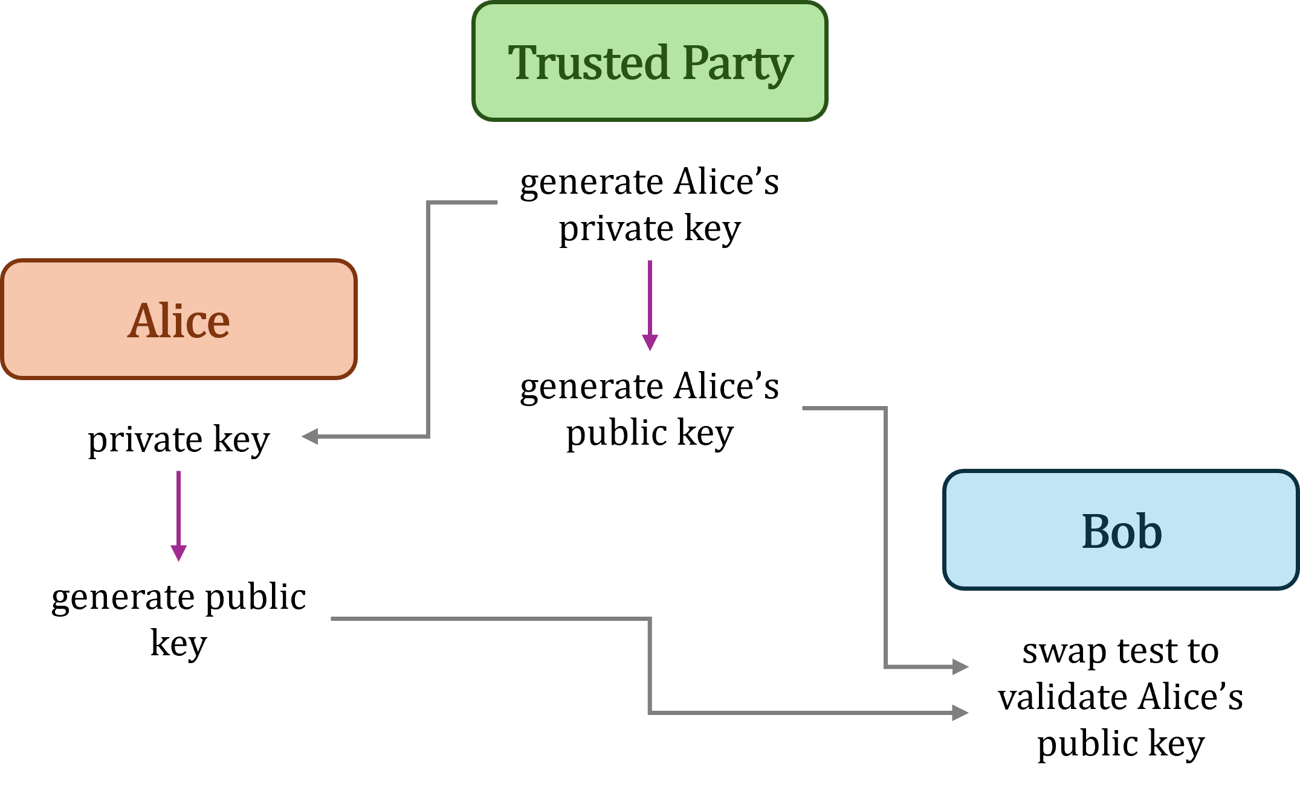

Figure 1

### *Qualitative vs quantitative data*

Most of the data produced by this methodology will be qualitative. The results will be dependent on whether or not the program described is able to be successfully created and run, and whether or not it is able to show that a secure connection can be established and used to transmit an encrypted message between Alice and Bob.

However, the randomness of the bitstreams created by the quantum random number generator will be determined using quantitative data, which will be produced by the tests that are contained within the NIST statistical test suite. (Rukhin et al., 2010)

### *Repeatability*

The methodology that has been outlined above is designed to be easily repeatable. The code of the program that is created will be provided in an appendix of this report so that it can be run and tested by a third party, or another program could be independently written by following the requirements and steps that have been laid out in the methodology. Using either of these methods, the efficiency, speed, and security of the exchange can be independently evaluated.

Independent testing of the randomness of the bitstreams produced by the quantum random number generator can be done using the tests contained in the NIST statistical test suite, (Rukhin et al., 2010) which is publicly available on the NIST website, or by using any other tests known to evaluate randomness.

### *Legal, ethical and social constraints*

The aim of this project, being the development of a secure encryption system, is important for many reasons, such as the protection of important information like sensitive data or intellectual properties, maintaining privacy by protecting conversations from unwanted surveillance, and preserving trust in digital communications by verifying identities online. Without encryption, secure communications over a network would be much more difficult, and the insecure communications that would replace them would be far less useful.

However, despite the importance of encryption, and the fact that there are currently no legal concerns associated with the goals of this project, there are some potential ethical considerations.

If a design for a perfectly secure system were to be created and shared, there would be no way to control who implemented it, or more importantly, what type of information it would be used to protect. For example, criminals would be able to share illegal content with one another without the potential for their communications to be intercepted by law enforcement, allowing them to pass their secrets back and forth freely, without fear of being caught.

As for the methods used in this project, there are no legal or ethical issues with any part of the methodology that is planned. No human participants will be involved in any way, so there are no concerns with needing to ensure that the collection and storage of any of the data that is used is in compliance with relevant data protection laws, and no part of the methodology is considered in any way illegal, so no safeguarding measures are required to be taken to protect either the author or the university.

## Implementation

*Quantum random number generator*

The first part of the program to implement is the quantum random number generator.

The function created will take the length of the random bitstream to be generated in bytes as an argument. For each byte needed, a quantum circuit will be created with eight qubits. A Hadamard gate will then be applied to each qubit to create an equal chance of producing a 0 or a 1. Finally, the quantum circuit will be executed and the qubits will be measured, and the returned results will be stored.

Once this process has been repeated enough times to produce the correct number of bytes, the random bytes will be combined into a single string which can then be returned.

The pseudocode for this is shown below:

function generate(length_in_bytes):

while in range 0 to length_in_bytes:

create quantum circuit with 8 qubits

for each qubit:

apply hadamard gate to qubit

execute circuit and measure all qubits

add measured values to results

return results

Since a new random byte will be generated for each letter in the plaintext, the quantum circuit that will be repeated each time will contain eight qubits, and can be represented by figure 2.

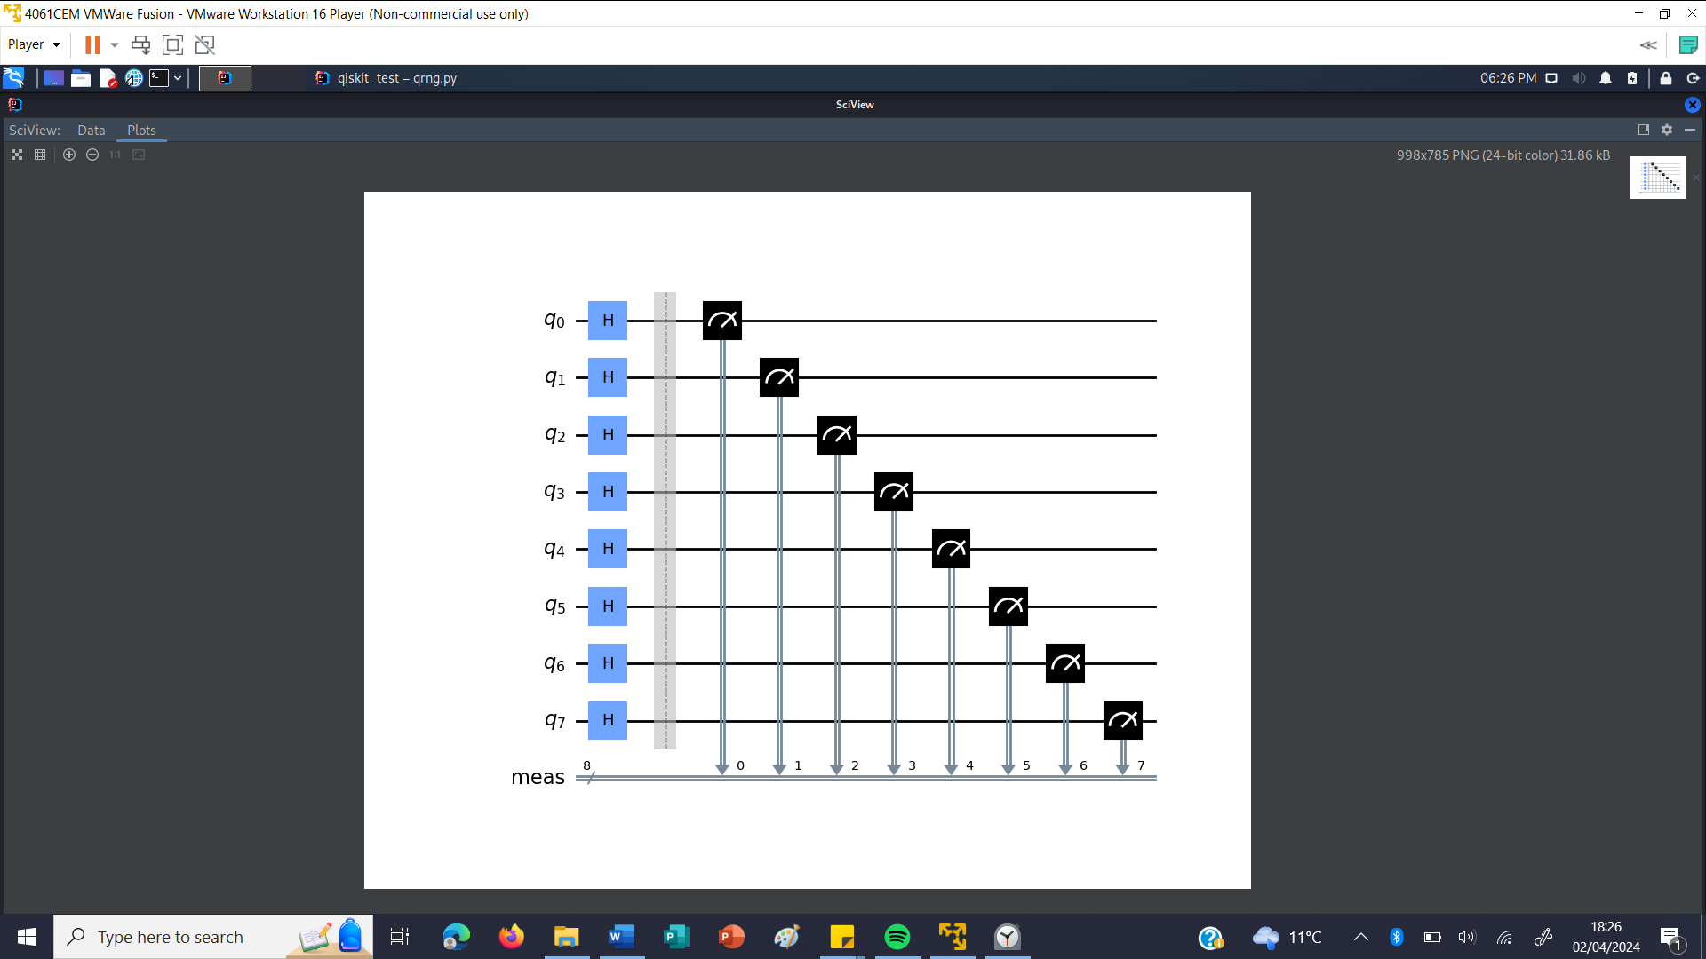

Figure 2

An alternative version of this function was also created, using the same process, with more qubits in each quantum circuit, to be able to more easily produce much longer bitstreams that could be used for randomness testing.

*BB84 key exchange*

The next part of the program to implement is the BB84 protocol.

The first function will be executed by Alice, and will take the message to be sent as an argument. It will then calculate the length of the message, which will be multiplied by a modifier in order to ensure that enough key bits are left after the BB84 exchange to be able to encrypt the full message.

Through testing various different lengths of messages with different modifiers, and seeing the length of time taken to generate a long enough key for each message, it was established that multiplying the length of the message by 2.25 provided long enough keys for the message with high enough frequency, while still ensuring that the function executed within a reasonable amount of time.

After multiplying the length of the message by 2.25, an extra 2 bytes are then added to the required length of the key, to use in checking that Alice and Bob’s keys match and that the exchange has not been intercepted or interfered with.

Next, two random bitstreams, of the calculated required length, will be created using the quantum random number function, one to be used as the initial key bitstream, and the other to indicate where Hadamard gates will be applied by Alice.

An array will then be created that can be used to hold a series of quantum circuits. This is necessary as there is a limit to the number of qubits that can be used in a quantum circuit, with the maximum number being 27. This would only be large enough to create a key capable of encrypting a 3 character message at most, and considering that approximately half of the bits will not be used in the final shared key, this is not long enough to be useful. Due to this, multiple quantum circuits will be needed to create a key that is long enough to encrypt a reasonable length of message.

To solve this problem, the initial random bitstreams will once again be broken down into bytes, with each pair of corresponding bytes from each bitstream being used to create one quantum circuit containing 8 qubits. If a bit of the initial key byte is 1, a Pauli-X gate will be applied to the corresponding qubit in the corresponding circuit. If the corresponding bit of the gate-indicating byte is 1, a Hadamard gate will be applied to the same qubit.

The array containing information about the structure of the quantum circuits will then be returned from the function to be sent to Bob. The reason for this is that qubits cannot be passed between the functions, due to the fact that this program is being run on a classical computer, so only classical data can be stored and sent. For the parts of the program that rely on quantum computing, information about the structure of the quantum circuits is sent as classical data and the circuits are simulated remotely using AerSimulator. The measured results from the execution of the circuits are then returned, once again as classical data.

The best way to simulate the passing of qubits is to instead pass the information about the gates applied by Alice to Bob, so that after Bob has added his own gates, the remote execution can be performed, and the qubits can be measured and results returned to Bob, just as they would be if the circuit was executed in two separate halves. Although the program is written so that Bob does not make use of this additional knowledge about the gates applied by Alice, in practice this would undermine the security of the key exchange, as information about the circuit being passed as classical data could be intercepted and copied by Eve.

The pseudocode for this function is shown below:

function alice_1(message):

length_in_bytes = (length of message * 2.25) + 2

alice_key = quantum random number generator.generate(length_in_bytes)

alice_gates = quantum random number generator.generate(length_in_bytes)

create array to hold circuits

for r in range 0 to length_in_bytes:

create quantum circuit with 8 qubits & append to circuits array

for q in range 0 to 8 (for each qubit):

if alice_key[(r*8 + q)] == 1:

apply Pauli-X gate to qubit q

if alice_gates[(r*8 + q)] == 1:

apply Hadamard gate to qubit q

return circuits array

The exact composition of each quantum circuit will depend on the random bitstreams generated, but for example, for an initial key byte of 00110011, and gate-indicating byte of 11110010, the structure of the quantum circuit could be represented by figure 3.

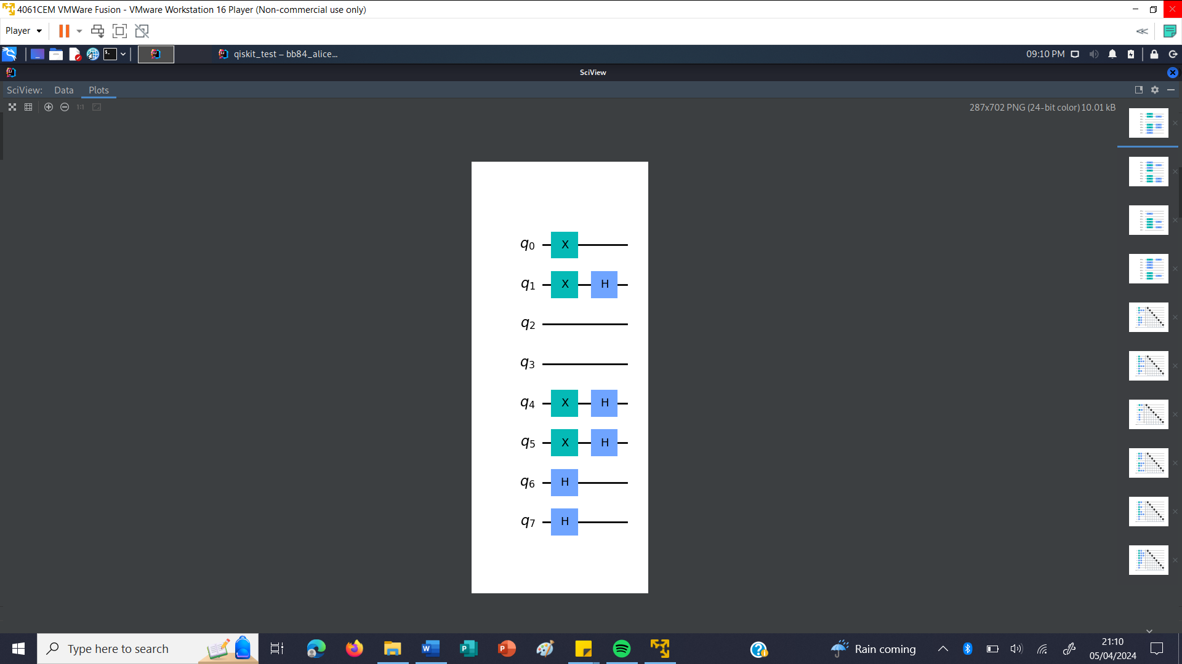

Figure 3

The next function needed will be executed by Bob, taking the array of circuits created by Alice as an argument.

First, the function will find the number of bytes in the initial key by getting the length of the array of circuits. Then, a random bitstream, of the same length as the initial key, will be created using the quantum random number function.

After this, for each circuit in the circuit array, and for each qubit in that circuit, if the corresponding bit of Bob’s random bitstream is 1, a Hadamard gate will be applied to the qubit.

Finally, each circuit in the array will be simulated, and the values of all the qubits will be measured. The resulting bytes will be joined together to create Bob’s key.

The random bitstream generated by Bob will then be returned from the function and sent to Alice.

The pseudocode for this function is shown below:

function bob_1(circuits):

length_in_bytes = length of circuits array

bob_gates = quantum random number generator.generate(length_in_bytes)

for r in range 0 to length_in_bytes:

for q in range 0 to 8 (for each qubit):

if bob_gates[(r*8 + q)] == 1:

apply Hadamard gate to qubit q

measure all qubits in circuit

add measured values to bob_key

return bob_gates

As with Alice’s circuits, the exact composition will depend on the random bitstreams generated by both Alice and Bob. However, after receiving Alice’s circuit shown above, and with a random gate-indicating byte of 01000110 generated by Bob, the structure of the quantum circuit after passing through this function could be represented by figure 4.

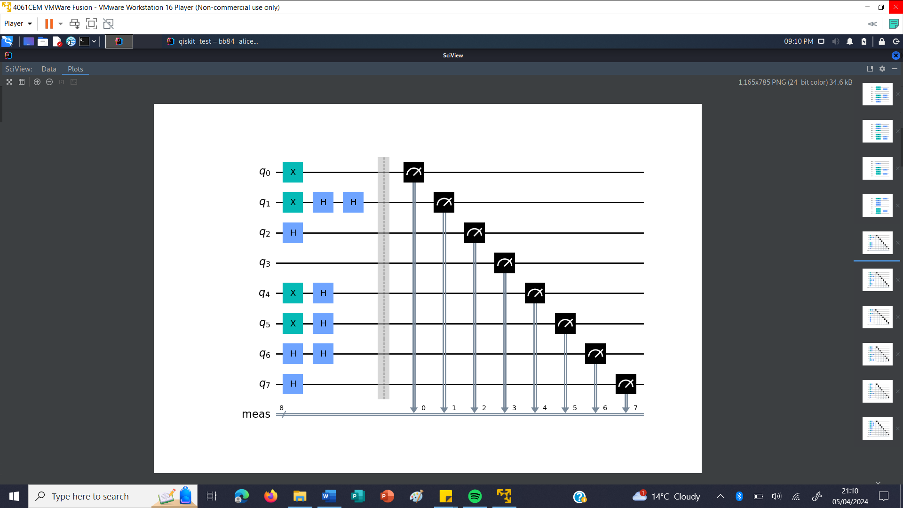

Figure 4

The next function will be executed by Alice, and will take the gate-indicating bitstream generated by Bob, showing where he applied his Hadamard gates, as an argument. It will then compare this with Alice’s gate-indicating bitstream, and create a new bitstream. Where the corresponding bits from these two bitstreams are the same, the corresponding bit from Alice’s initial key will be added to her shared key, and a 1 will be added to the comparison bitstream. Where the bit values are different, a 0 will be added to the comparison bitstream.

The comparison bitstream will then be returned by the function to be sent to Bob.

The pseudocode for this is shown below:

function alice_2(bob_gates):

for count in range 0 to length of alice_gates:

if alice_gates[count] == bob_gates[count]:

add alice_key[count] to alice_shared_key

add 1 to end of comparison bitstream

else:

add 0 to end of comparison bitstream

return comparison bitstream

The next function needed will be executed by Bob, and will take the comparison bitstream generated by Alice as an argument.

For each bit in the comparison bitstream, if the value of the bit is 1, the corresponding bit of Bob’s key will be added to his shared key. The first two bytes of Bob’s shared key will then be removed and returned from the function and sent to Alice.

The pseudocode for this function is shown below:

function bob_2(comparison):

for count in range 0 to length of comparison:

if comparison[count] == 1:

add bob_key[count] to bob_shared_key

remove first 2 bytes from bob_shared_key & add to bob_check

return bob_check

The final function will be executed by Alice, taking the first two bytes of Bob’s shared key, and the message to be sent by Alice as arguments. The first two bytes of Alice’s shared key will be removed and compared to the bytes sent by Bob. If the bytes match, this means that Alice and Bob likely have the same shared key, which can be used to encrypt the message, and the exchange has not been intercepted.

The function will also check if the shared key generated by this process is long enough to be used to encrypt the message that Alice wants to send.

If both of these conditions are satisfied, the function will return true, and both Alice and Bob will have a shared key that can be used by Alice to encrypt a message that can then be sent securely and decrypted by Bob.

If either Alice and Bob’s bytes do not match, or the key is too short for the message, the function will return false, and the key exchange process will have to be repeated again from the beginning.

The pseudocode for the final function is shown below:

function alice_3(bob_check, message):

valid = False

remove first 2 bytes from alice_shared_key & add to alice_check

if alice_check == bob_check AND (length of alice_shared_key / 8) >= length of message:

valid = True

return valid

*One-time pad cipher*

The next part of the program to implement is the one-time pad cipher.

The first function needed is one to encrypt a message, taking the message string to encrypt and the key bitstream as arguments. First, the message string will be converted to a binary bitstream. Then, both the message bitstream and the key bitstream will be split into bytes.

For each byte in the message bitstream, the corresponding key byte will be added to it. The remainder of the resulting value divided by 96 will then be calculated, and 32 will be added to the result. This will give the value of the corresponding byte of ciphertext. Each byte of ciphertext calculated will be added to the ciphertext bitstream, which once complete, will then be converted back to a string before being returned from the function.

The pseudocode for this function is shown below:

function encrypt(message, key):

plaintext = convert message from string to binary

split plaintext into bytes

split key into bytes

for x in range 0 to (length of plaintext // 8):

ciphertext_byte = ((plaintext_byte + key_byte) % 96) + 32

add ciphertext_byte to ciphertext

convert ciphertext from binary to string

return ciphertext

The next function needed is one to decrypt a message, and will take the message string to decrypt and the key bitstream as arguments. First, the message string will be converted to a binary bitstream. Then, both the message bitstream and the key bitstream will be split into bytes.

For each byte in the message bitstream, 32 will be subtracted from the value of the ciphertext byte, and then the value of the corresponding key byte will be subtracted from that value. If the resulting value is less than 32, 96 will be added. This will give the value of the corresponding byte of plaintext. Each byte of plaintext calculated will be added to the plaintext bitstream, which once complete, will then be converted back to a string before being returned from the function. If the same key is used to encrypt and decrypt, the returned string should be the original plaintext message that was encrypted.

The pseudocode for this is shown below:

function decrypt(message, key):

ciphertext = convert message from string to binary

split plaintext into bytes

split key into bytes

for x in range 0 to (length of ciphertext // 8):

plaintext_byte = (ciphertext_byte - 32) - key_byte

while plaintext_byte < 32:

plain_byte += 96

add plaintext_byte to plaintext

convert plaintext from binary to string

return plaintext

*Authentication*

The final part of the program to implement is the authentication.

The first function needed is one to create a private key and save it to a file so it can be accessed later, taking the file path as an argument. Since this is only a proof-of-concept program, with only two private keys needed to be able to test, the private keys will be generated using the quantum random number generator function, since the chance of this producing two identical keys is very small. With more people to authenticate, measures would need to be put in place to ensure that no two private keys were the same.

For this version, 10 bytes are used for the private key, however this can be easily changed, and the ideal number of bytes will depend on several factors, such as the number of people needing to be authenticated, as longer private keys will allow for more unique keys to be created with fewer similarities between keys, as well as the execution speed required for the authentication process.

The pseudocode for this function is shown below:

function create_private(filepath):

length_in_bytes = 10

private_bitstream = quantum random number generator.generate(length_in_bytes)

open file(filepath)

write private_bitstream to file

close file

The next function will read a private key from a file and use it to generate the corresponding public key, taking the filepath to the private key file as an argument.

After reading in the private key bitstream, an array will be created that can be used to hold a series of quantum circuits, each containing 1 qubit. This is so that later, when the swap tests are performed, a circuit from the public key array created by the person wanting to be authenticated, and the corresponding circuit from the trusted public key array can be combined into one circuit and the swap test can be performed.

For each bit in the private key bitstream, a quantum circuit containing 1 qubit will be created, and if the value of the private key bit is 1, a Pauli-X gate will be applied to the qubit. Then, a Hadamard gate will be applied to each qubit to place it into a state of superposition. The public key array containing information about the structure of the quantum circuits will then be returned from the function.

The pseudocode for this is shown below:

function create_public(filepath):

open file(filepath)

private_key = read file

close file

create array to hold public_key circuits

for i in range 0 to length of private_key:

create quantum circuit with 1 qubit & append to public_key array

if private_key[i] == 1:

apply Pauli-X gate to qubit of public_key[i]

apply Hadamard gate to qubit of public_key[i]

return public_key array

The final function needed will perform the swap test to check a public key created by a person wanting to be authenticated against the trusted public key for that person, and will take the two public keys to test as arguments.

First, a boolean variable will be created to show whether or not a 1 has been returned from any of the swap tests, as this would indicate that the public keys did not match and show that the authentication had failed.

Then, for each bit in the public key to be tested, a quantum circuit will be created with 3 qubits and 1 classical bit. A circuit from the public key array to be tested will be added to the second qubit in the swap circuit, and the corresponding circuit from the trusted public key array will be added to the third qubit. A Hadamard gate will then be applied to the first qubit in this circuit. A swap test will then be done with the 3 qubits of the swap circuit, before another Hadamard gate is applied to the first qubit.

Each swap circuit will then be simulated using AerSimulator, and the value of the first qubit will be measured. If any of these values are a 1, it will show that the two public keys are different, and the variable showing whether the authentication has passed will be set to false.

The variable showing whether the public key has been successfully authenticated will then be returned from the function.

The pseudocode for this is shown below:

function swap_test(test_key, trusted_key):

valid = True

for y in range 0 to length of test_key:

swap_circuit = create quantum circuit with 3 qubits and 1 classical bit

add test_key[y] circuit to second qubit of swap_circuit

add trusted_key[y] circuit to third qubit of swap_circuit

apply Hadamard gate to first qubit of swap_circuit

perform a swap test on the 3 qubits of swap_circuit

apply Hadamard gate to first qubit of swap_circuit

measure first qubit of swap_circuit

if measured value == 1:

valid = False

return valid

With each swap test circuit containing three qubits, two of which may or may not have had a Pauli-X gate applied to them when the public key was created, there are four possible compositions for each swap test circuit that is created, shown by figures 5 to 8.

In the circuits shown in figures 5 and 6, the qubits from both the public key being tested and the trusted public key are the same, and once executed, the value of the first qubit will always be 0. In the circuits shown in figures 7 and 8, the qubits are different, and once executed, the value of the first qubit will have a 50% chance of measuring either a 0 or a 1.

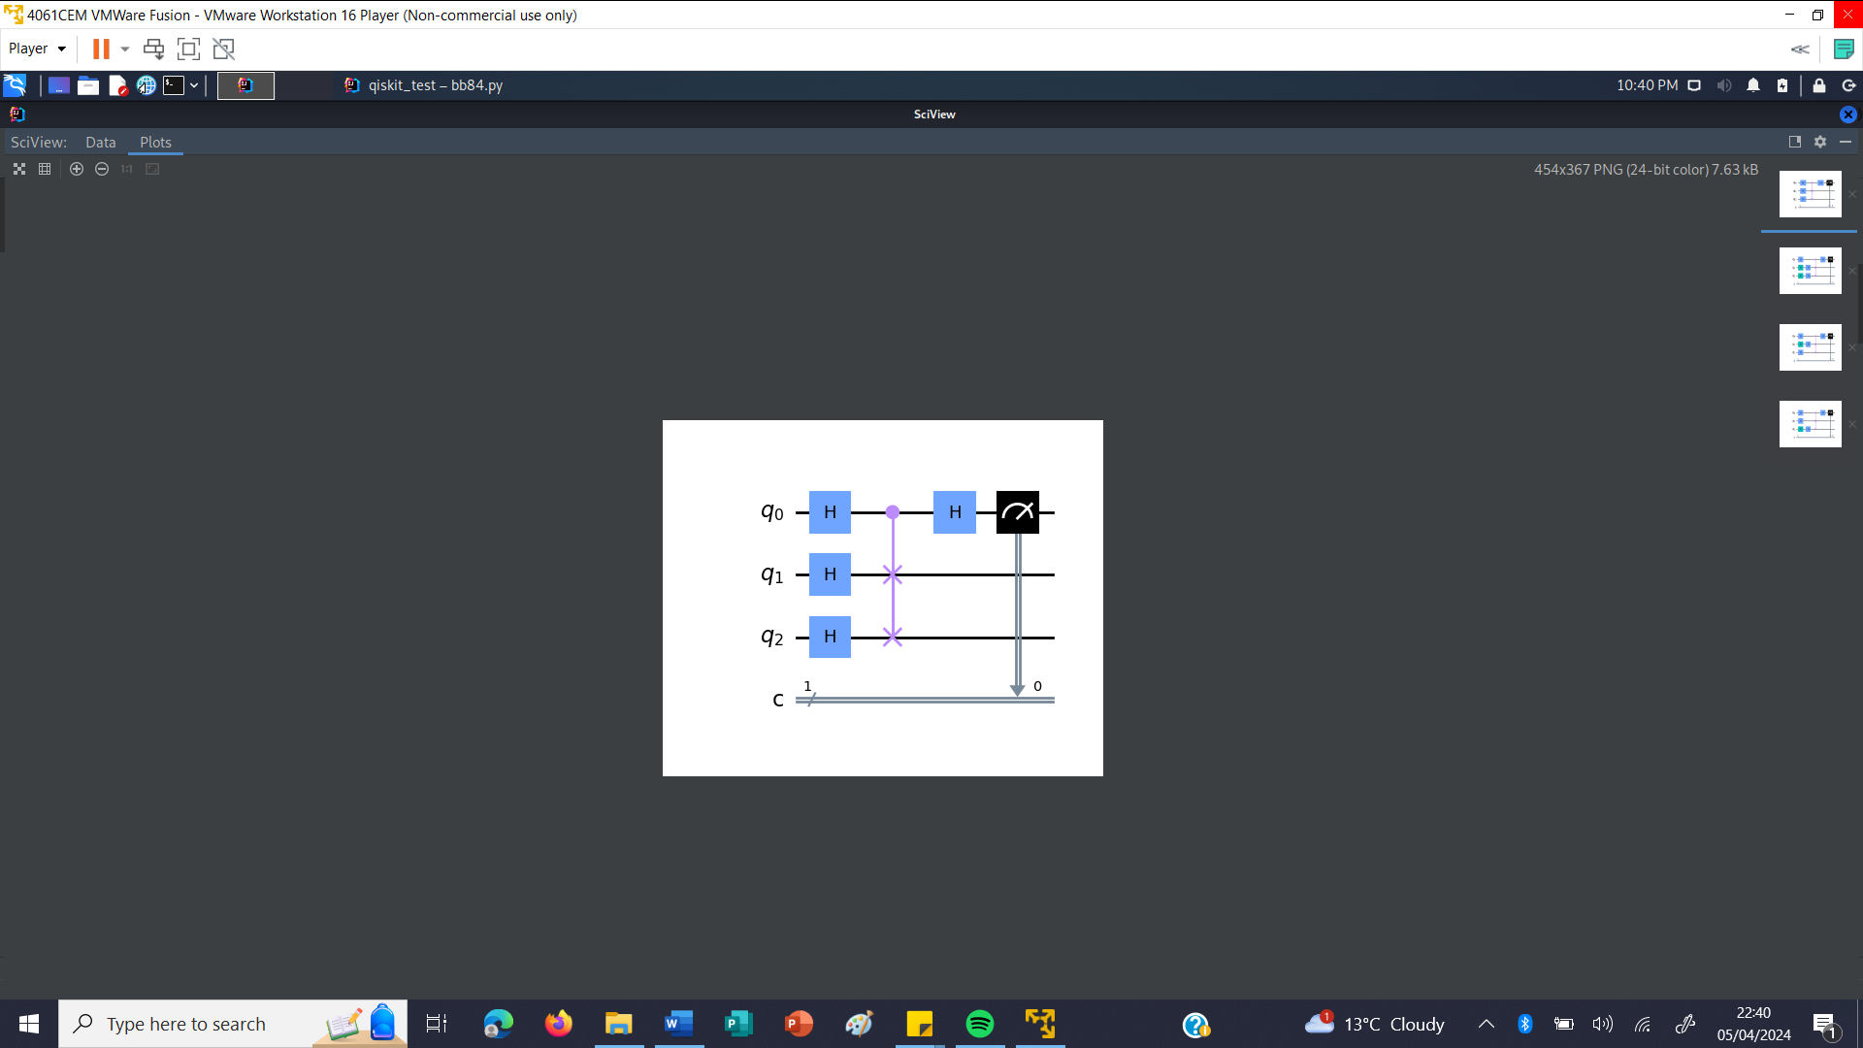

Figure 5

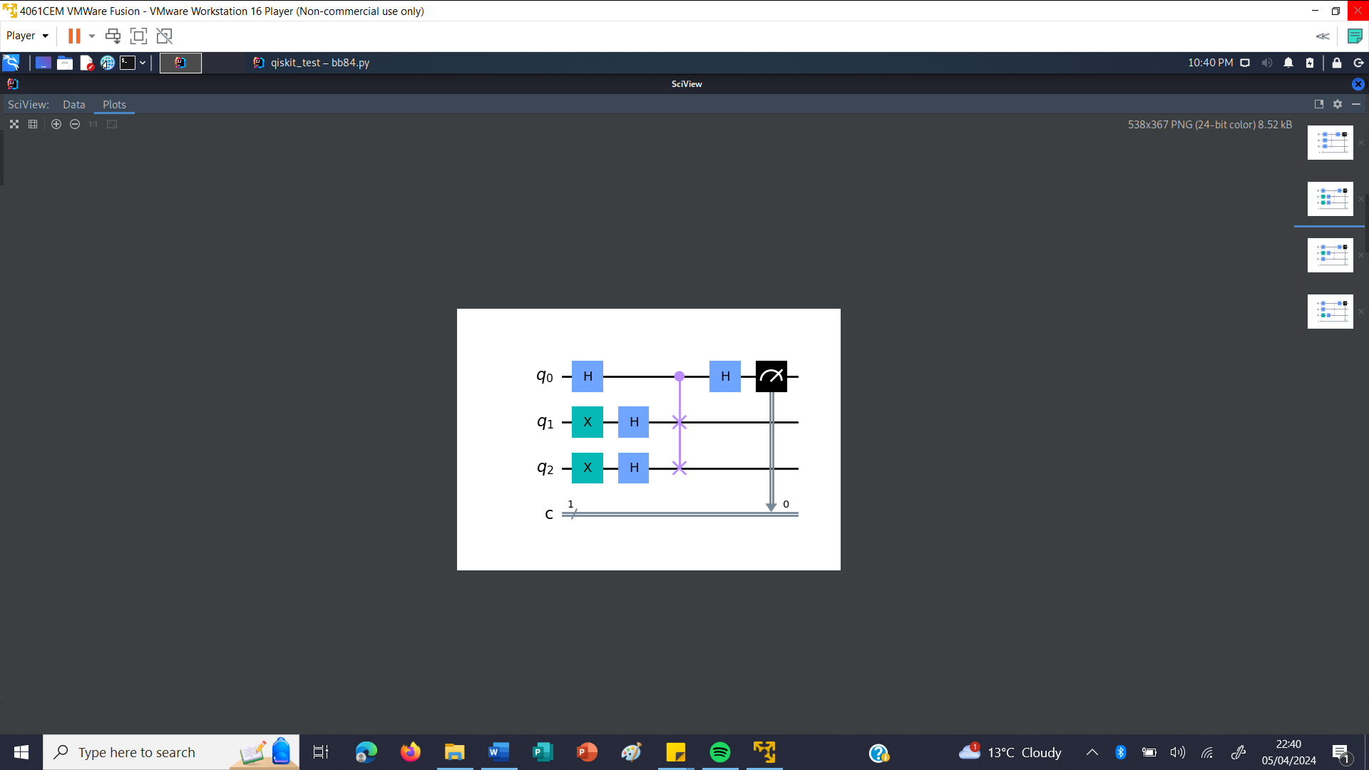

Figure 6

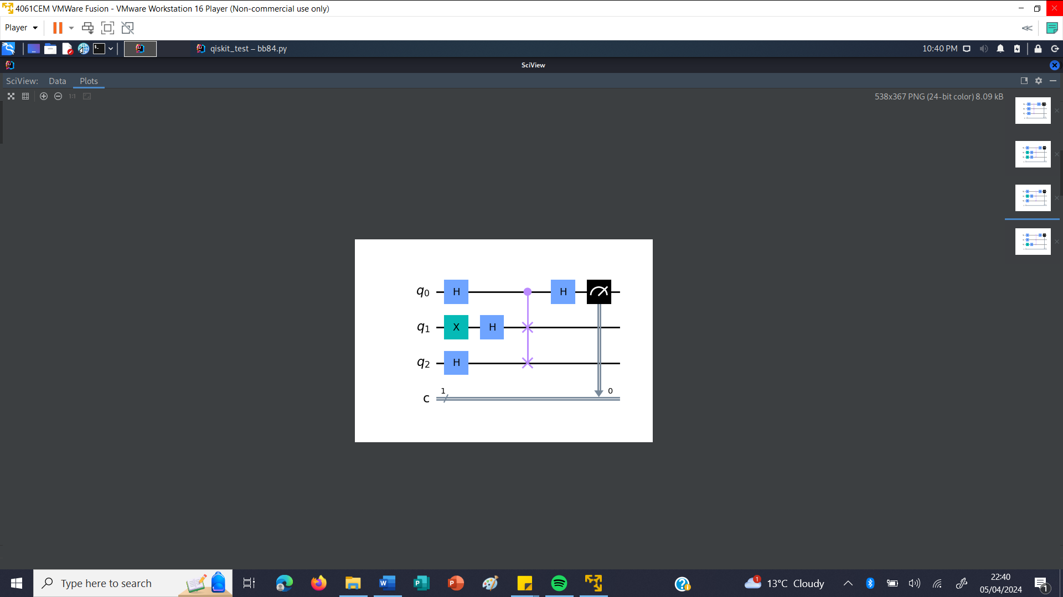

Figure 7

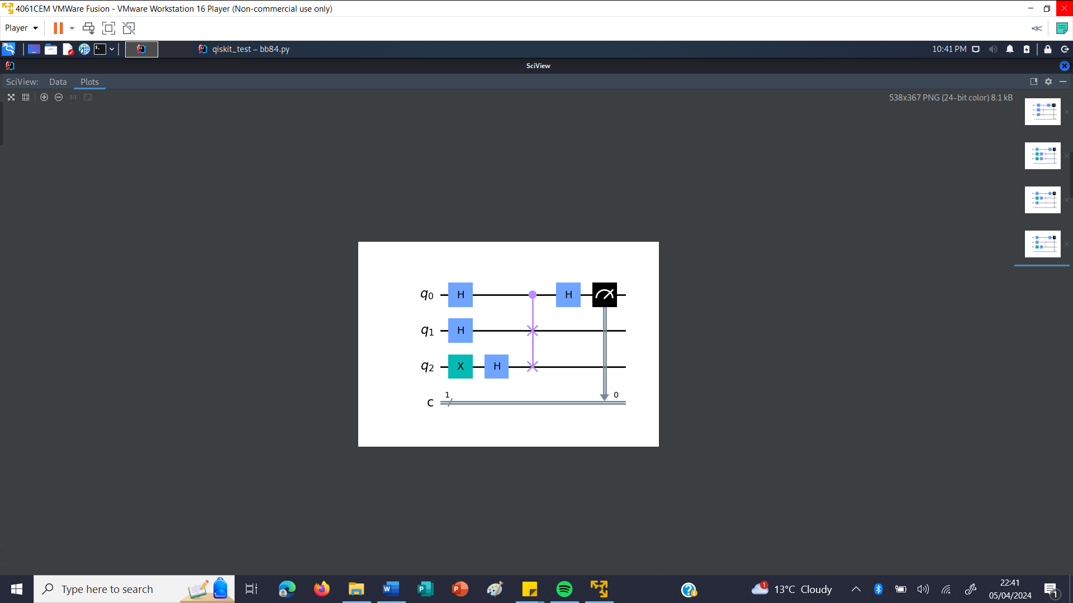

Figure 8

## Evaluation

### *Testing*

The first part of the program to test was the authentication. This was done by creating two private keys – one for Alice and one for Eve – and attempting to be authenticated as Alice using both keys.

The result of using Eve’s private key in the authentication attempt is shown in figure 9. The program was able to recognise, based on the comparison of Eve and Alice’s public keys, that the two were different, and successfully shut down the communication with Bob.

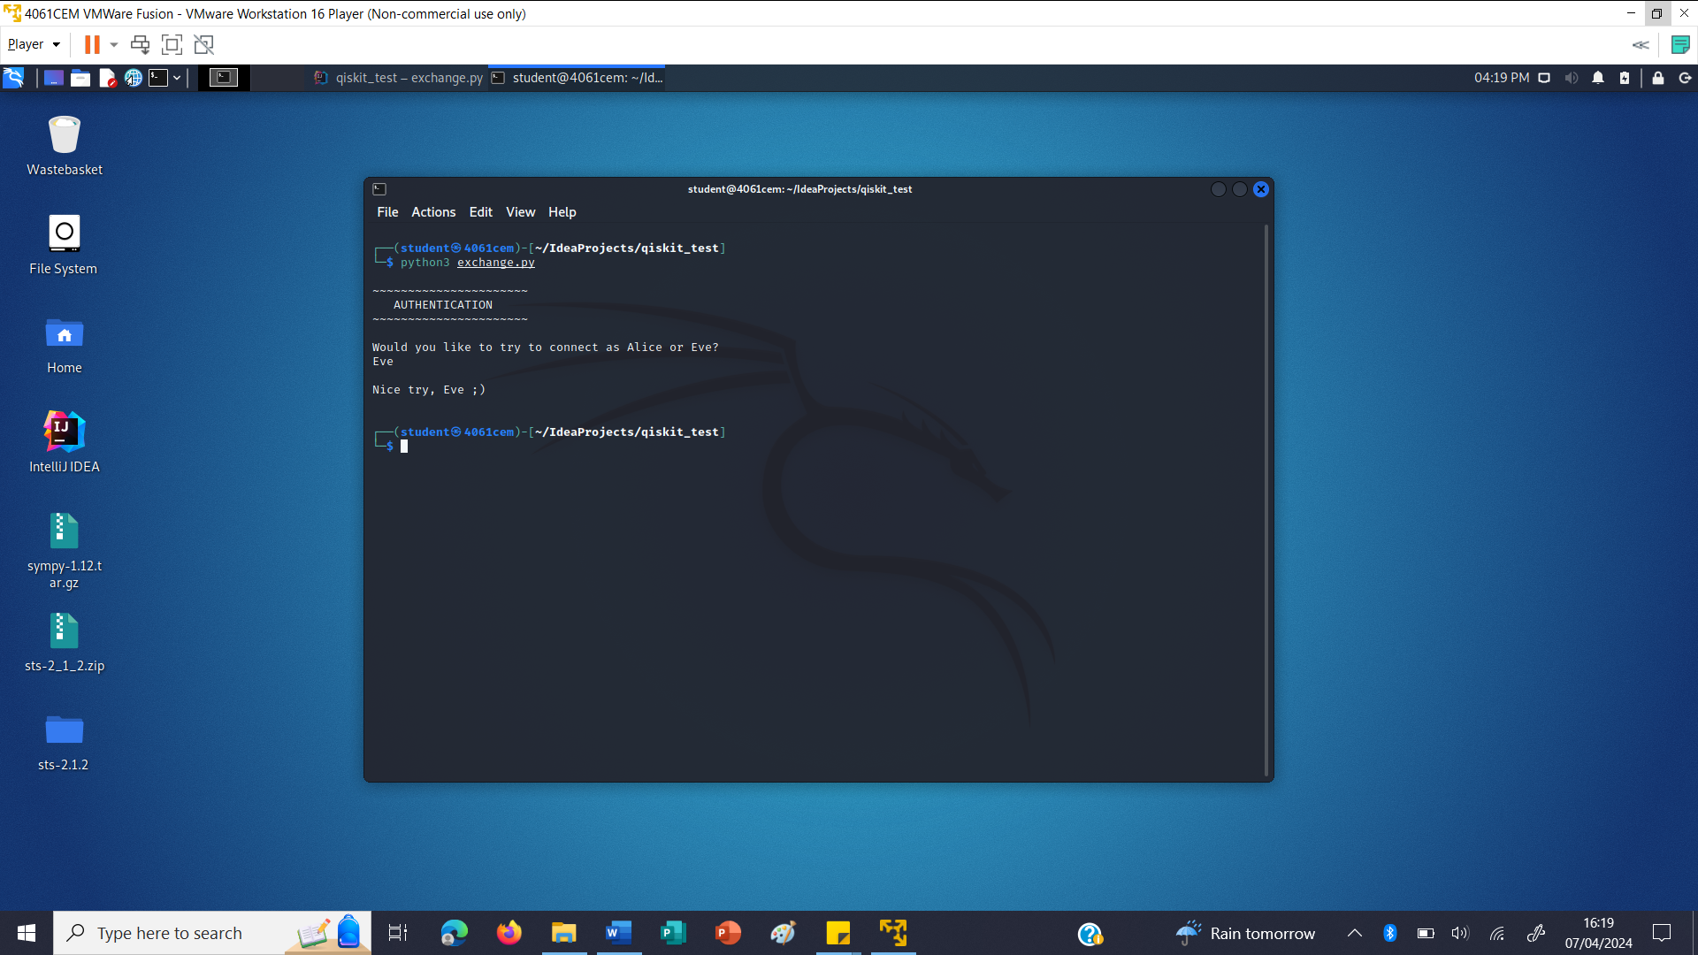

Figure 9

However, when using Alice’s private key to authenticate, as shown in figure 10, the program was able to recognise Alice and allow her to enter a message to send to Bob.

The next test was of the BB84 key exchange, also shown in figure 10. The protocol was used to establish a shared key, long enough to encrypt Alice’s message, between Alice and Bob. The results of the key exchange were printed to show that the keys held by both Alice and Bob were identical, proving that the key exchange had been completed successfully.

The final test was of the one-time pad encryption and decryption, once again shown in figure 10. The message entered by Alice was encrypted with the one-time pad cipher, using Alice’s key, and decrypted using Bob’s key, showing that Bob was able to successfully and securely obtain the message from Alice.

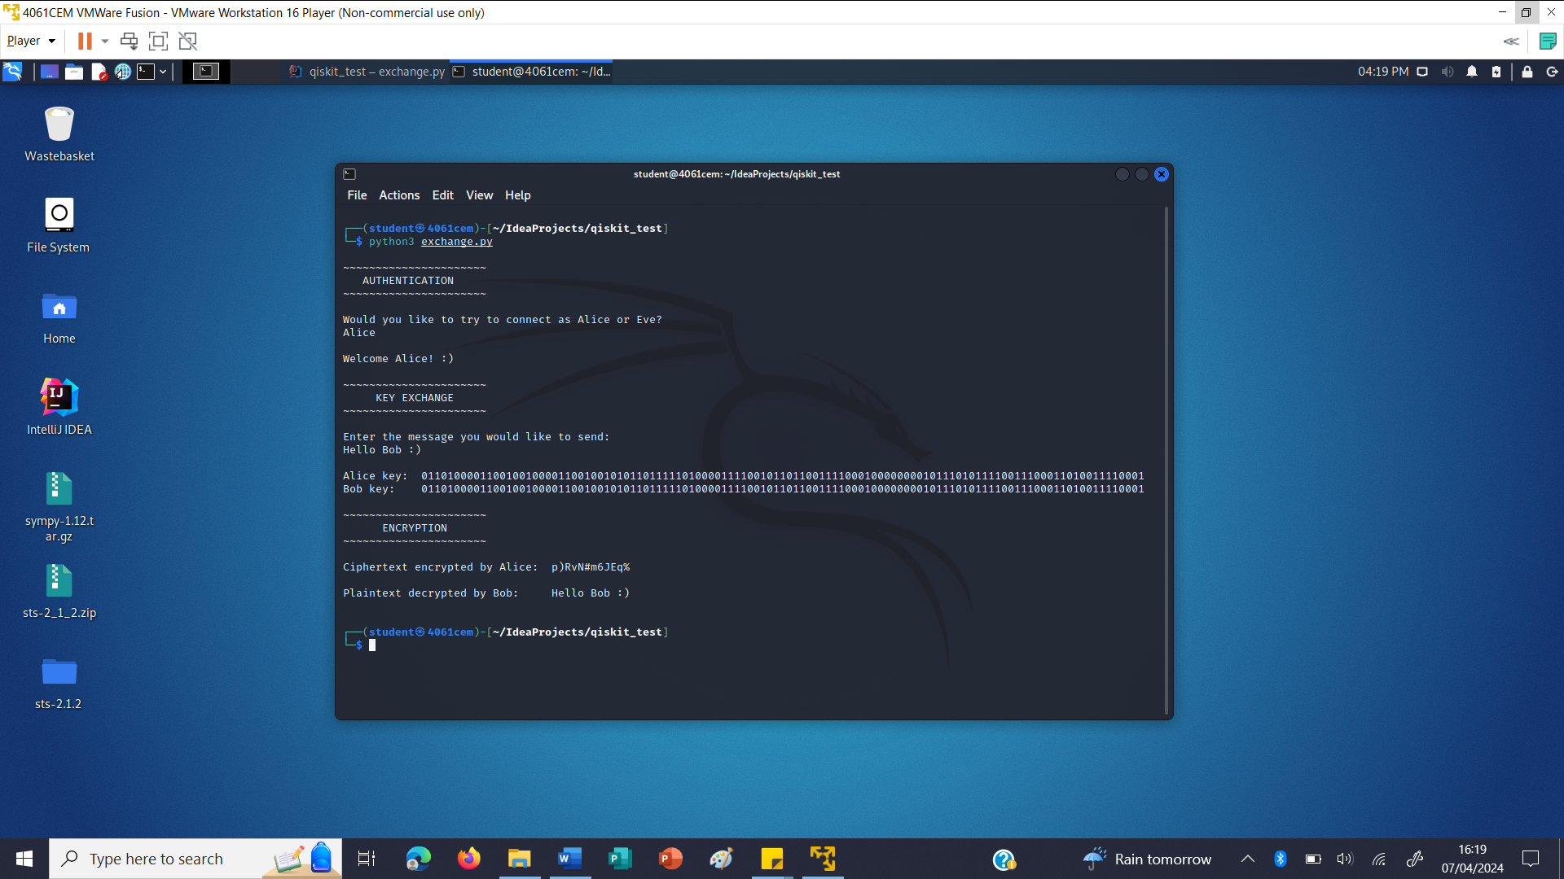

Figure 10

Another test was then completed with a longer message sent from Alice to Bob, shown in figure 11. Once again, Alice was able to be authenticated, a shared key of appropriate length was established between Alice and Bob, and Alice’s message was able to be encrypted by her, and successfully decrypted by Bob.

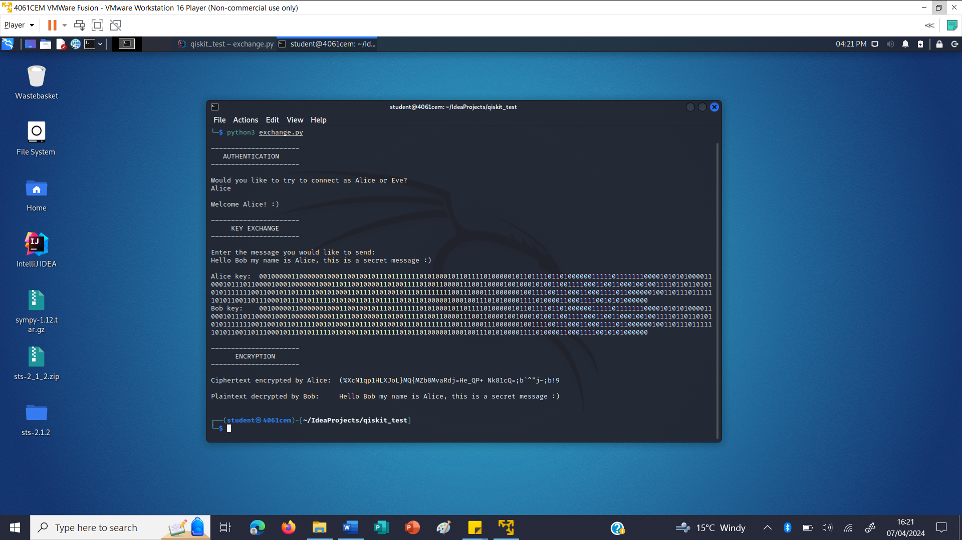

Figure 11

*Randomness tests*

The final test needed was whether or not the random bitstreams produced by the quantum random number generator were truly random enough to be suitable for use as secure cryptographic keys for the one-time pad encryption.

This was done using an implementation of the NIST statistical test suite, found at the following website: <https://mzsoltmolnar.github.io/random-bitstream-tester/>

First, a 1,000,000 bit value was generated using the alternative quantum random number generator function. This bitstream was then tested, the results of which are shown in figures 12 and 13.

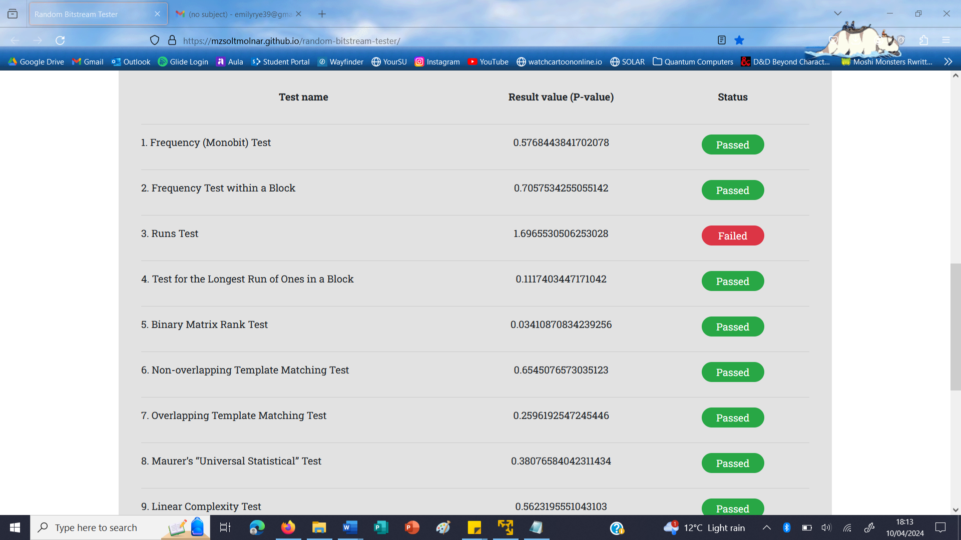

Figure 12

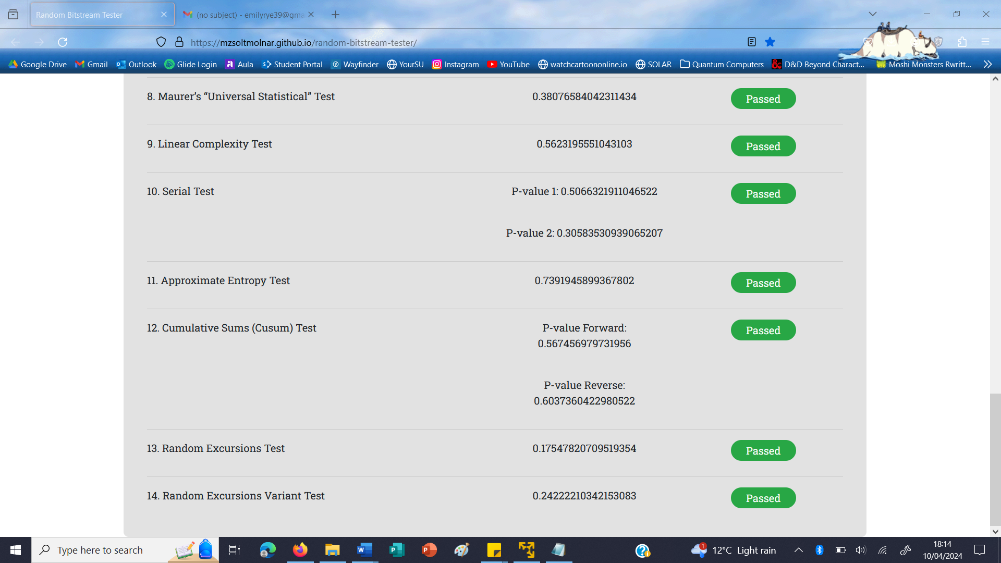

Figure 13

These results show that the random bitstream produced by the quantum random number generator function passed 13 of the 14 tests in the test suite, only failing one test.

Another 1,000,000 bit value was then generated, using the same quantum random number generator function, and the tests were run again. The results of the second bitstream are shown in figures 14 and 15.

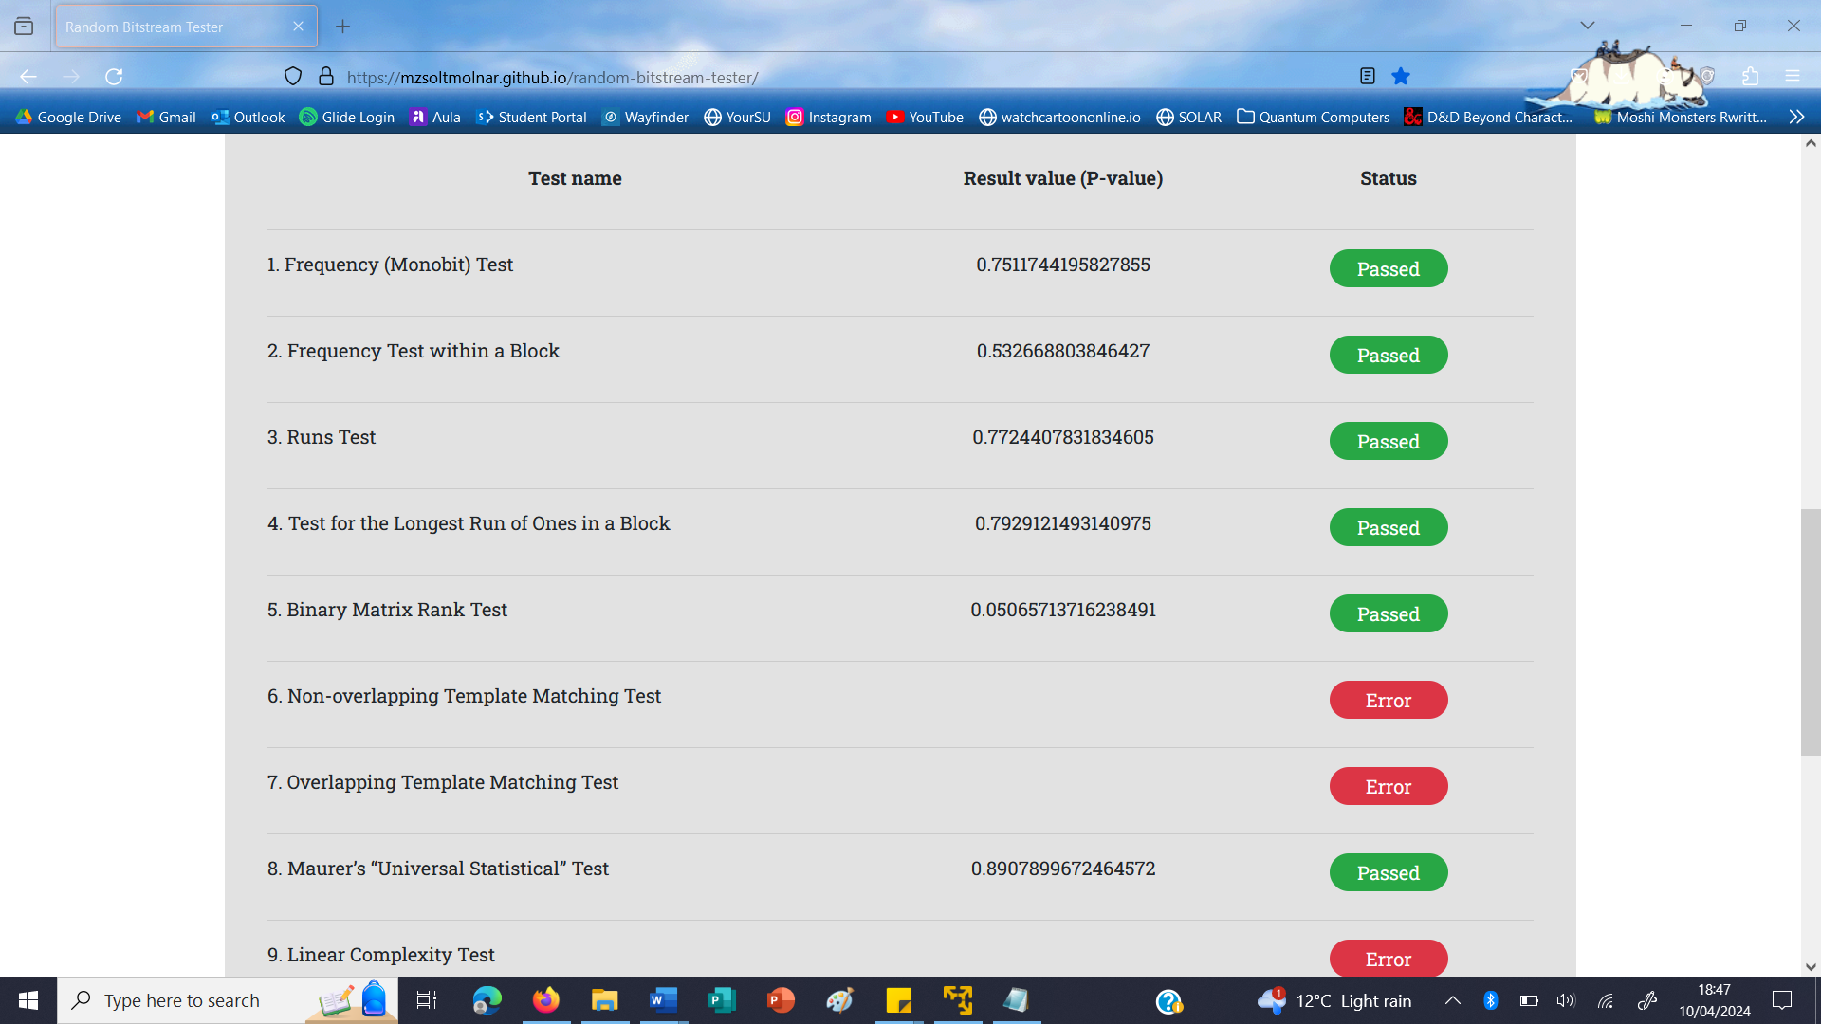

Figure 14

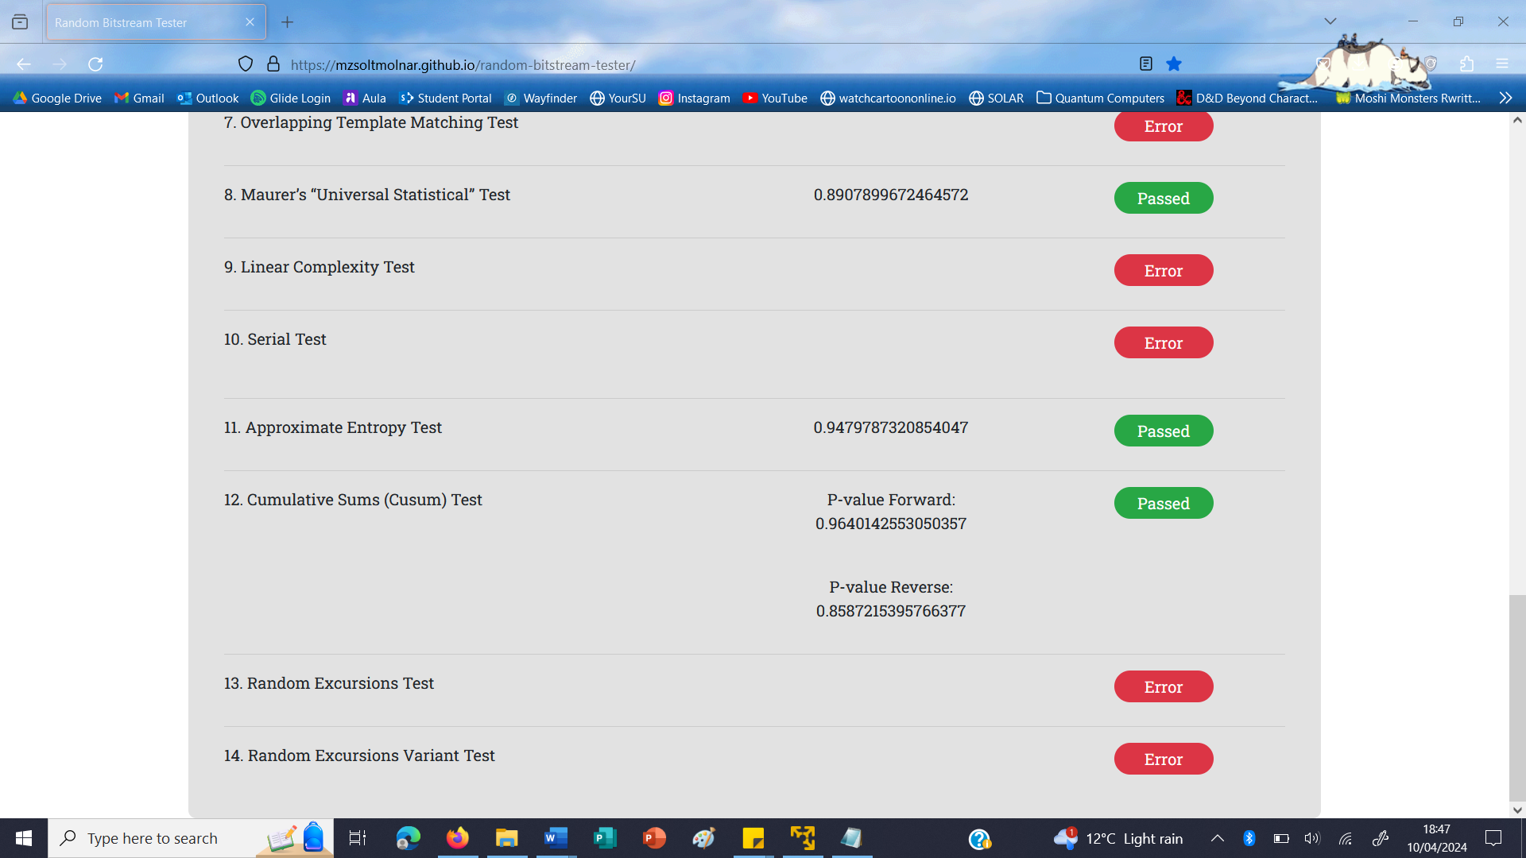

Figure 15

Although 6 of the tests failed to run on the second bitstream, producing errors and therefore remaining inconclusive, the test which had previously failed on the first bitstream was successfully passed by the second bitstream, as well as every other test that managed to run successfully.

For comparison, the results of a random bitstream of the same length that was generated using radioactive decay as a source of entropy are shown in figures 16 and 17.

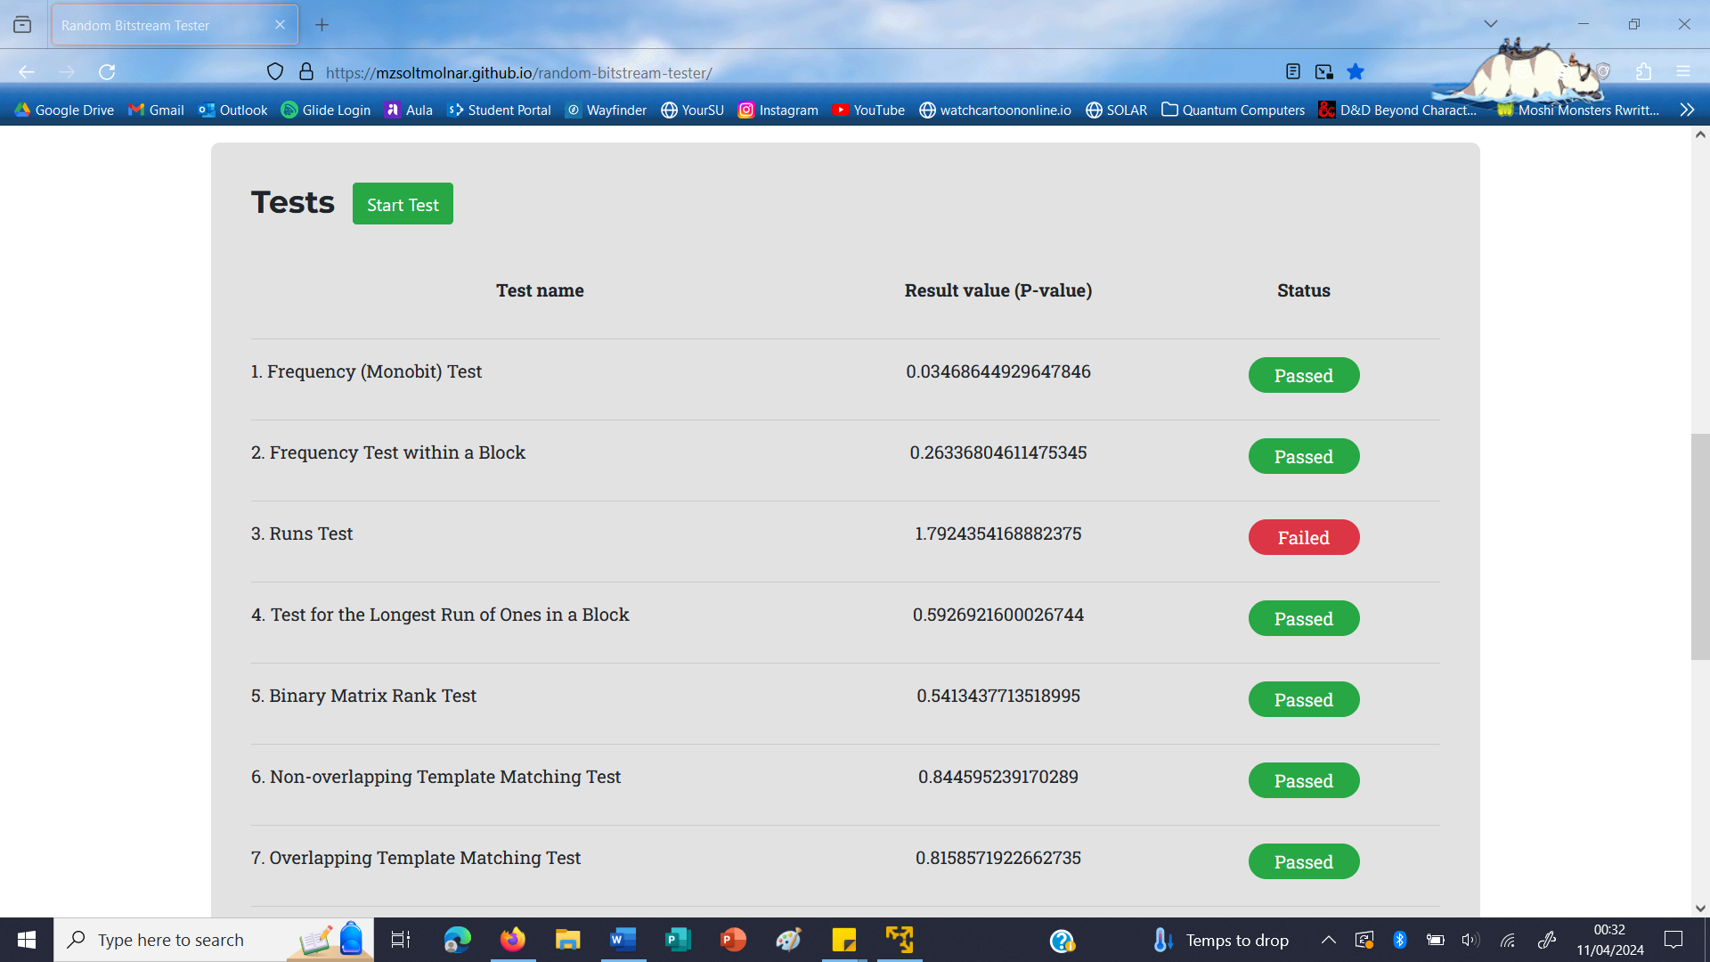

Figure 16

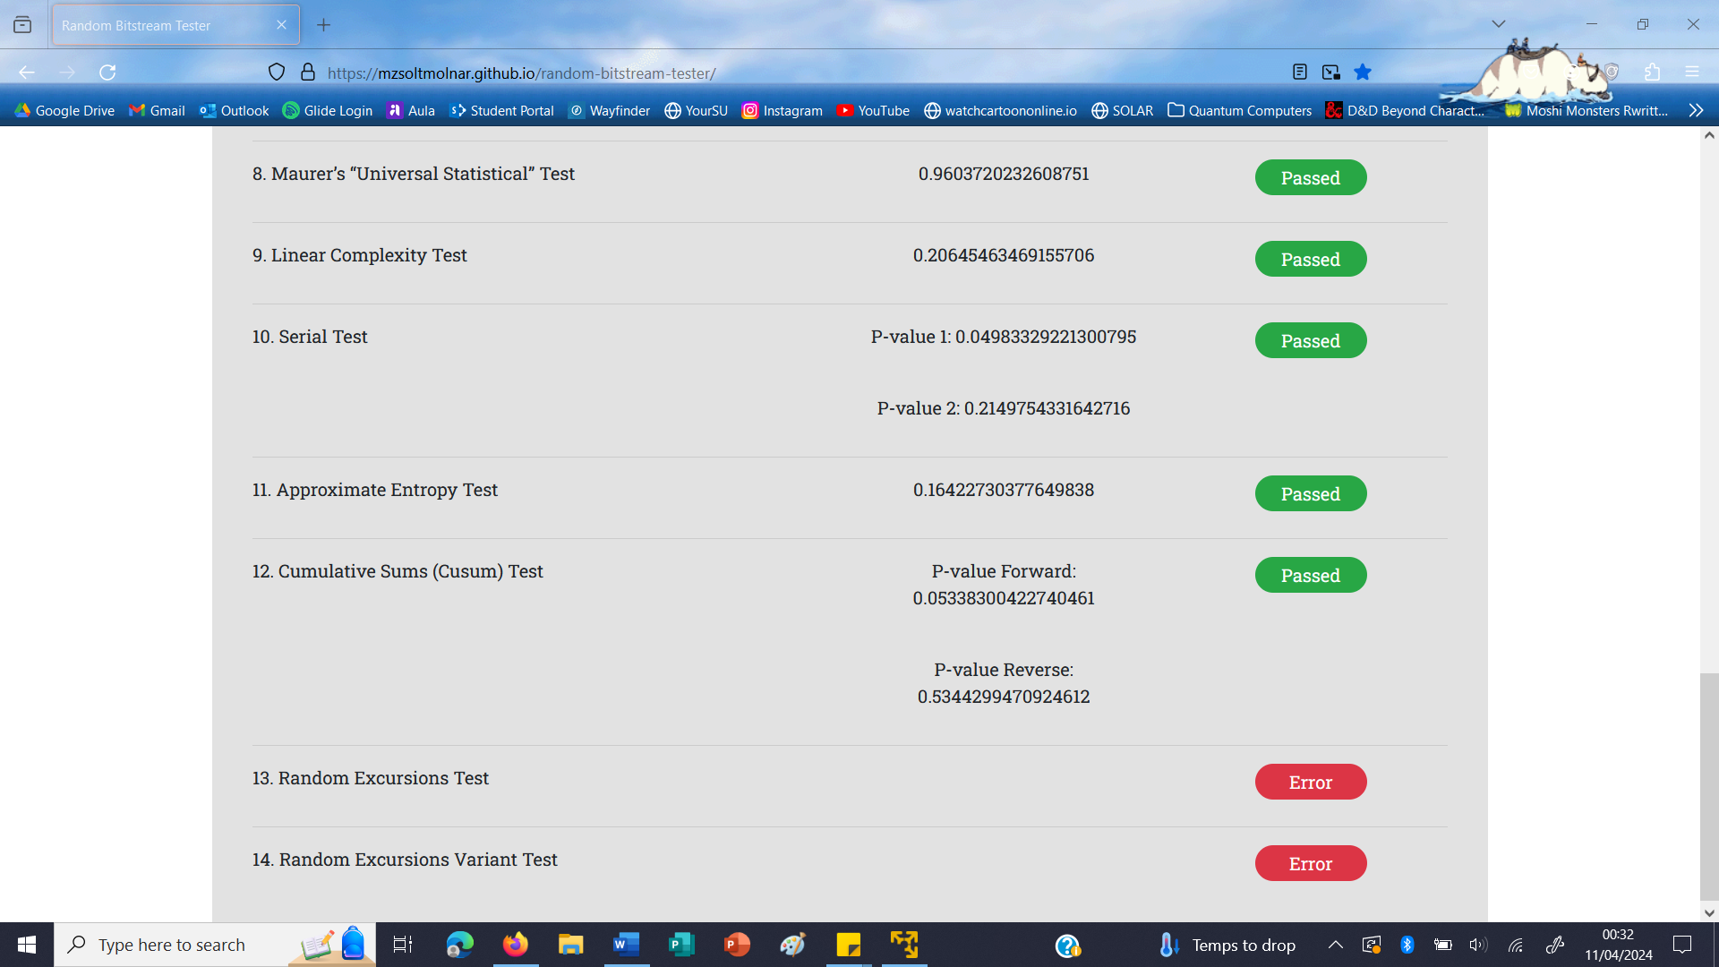

Figure 17

The bitstream produced by radioactive decay also failed the 3rd test, the same one that was failed by the first random bitstream produced by the quantum random number generator. In fact, the result value produced by the test for the radioactive decay bitstream was the highest value produced by any of the three different bitstreams, and was therefore the worst result produced for this test.

Errors were also produced on 2 of the 6 same tests that generated errors on the second quantum random number generator bitstream. All other tests were successfully passed.

Based on this comparison, these results show that the quantum random number generator function is capable of producing values that are considered sufficiently random, and are suitable for use as cryptographically secure keys.

### *Strengths and weaknesses of the system*

The use of the one-time pad cipher makes the messages encrypted with this system extremely secure, since the randomness of the key means that any original value of the plaintext is possible, making it impossible to find without knowledge of the exact key that was used for encryption.

Since the values generated by the quantum random number generator that was developed were shown to be truly random enough to be sufficiently secure as cryptographic keys, the encryption of the messages would be perfectly secure, and impossible for Eve to fully decrypt without having knowledge of the entire key that was used.

The BB84 key exchange protocol is also very secure, since the qubits sent from Alice to Bob are in a state of superposition, and therefore cannot be read or copied by Eve without disrupting the exchange.

The randomness of the bitstreams generated, that are used to decide both the initial key, and which qubits Alice applies Hadamard gates to, means that these values would be impossible for Eve to predict. If any attempt was made to guess, since she would have no way to tell whether or not she had guessed correctly before disrupting the communication between Alice and Bob, her presence would almost certainly be detected by Alice and Bob. The qubits that Hadamard gates are applied to also change in each key exchange according to a new random bitstream that is generated each time, so even if Eve were able to guess correctly, she would only be able to read the contents of one message.

The main weakness of the system is in the authentication. This is because for each qubit of the public key sent by the person wishing to be authenticated that does not match the corresponding qubit of the trusted public key, there is only a 50% chance that this will be shown by the swap test.

By using longer keys, the chances of an incorrect key being successfully authenticated are reduced, as the more swap tests are performed on incorrect qubits, the higher the chances are of the difference being identified. However, if Eve were able to obtain even a part of Alice’s private key, this would increase the chances of her being able to successfully impersonate Alice, since the number of incorrect qubits in the key, and therefore the odds of those differences being shown by the swap tests, would be once again reduced. Since each person’s private key is also a fixed value, Eve would be able to attempt authentication as Alice multiple times, which could allow her to obtain information about Alice’s private key by testing different values against Alice’s public key.

A similar issue would also arise from adding more people needing to be authenticated to the system. Although a 10 byte private key would theoretically have enough bits to create more than enough distinct keys, the similarities between the private keys assigned would need to be carefully considered to ensure that there was not enough overlap to pose a significant risk of confusion between keys, with one being successfully authenticated as another.

Even with the risks being minimised as much as possible, there is still a small chance that even two keys with no similarities between them will not be identified as being different by the swap tests. Although with a 10 byte key the chances of this are very small, if this system were to be used on a large enough scale, the risk would need to be considered.

# **Conclusions and future work**

## Conclusion

The original aim of this project was to determine whether quantum cryptographic techniques could be used to overcome the practical limitations of the one-time pad cipher.

This goal remained the same throughout the project, and the conclusion that was found is that it is possible, using quantum computing and some of the new cryptographic techniques that have been developed with it, to create an implementation of the one-time pad cipher that could be practically used in day-to-day communications, where no prior knowledge is required by either of the parties in order to establish a secure communication.

The system that was created as part of this project is capable of generating a random bitstream, of a suitable length for the message that is being sent, and truly random enough to be suitable for being used as a cryptographic key. This bitstream is then exchanged between the two parties wishing to communicate by using an implementation of the BB84 key exchange protocol. This process creates a key that is then held by both parties.

Finally, the one-time pad cipher is used to encrypt a message using the first party’s key, and decrypt that message using the second party’s key. The final message received by the second party after being decrypted matches the original plaintext that was sent by the first party, showing that the message has been successfully communicated between both parties.

The system also includes a method of authentication, to ensure that the identities of those wishing to exchange secure messages can be verified, so that someone trying to gain information cannot do so by impersonating a trusted party.

The methodology that was described was mostly able to be successfully followed, although there are places where, due to limitations with the hardware available for execution, certain parts of the system were not able to be correctly implemented, making the key exchange and authentication methods insecure.

If quantum information were able to be passed between functions in the program, as it would be passed between the parties in a real-world scenario, the uncertainty principle and the no-cloning theorem of quantum mechanics would prevent this information from being able to be intercepted by an eavesdropper. However, since this program is only able to pass classical information, instead of qubits, information about the circuits needed to create the qubits must be passed instead, meaning that an eavesdropper would be able to obtain this information and recreate the circuits needed to create the correct qubits.

These insecurities have been identified in the implementation section of this report, and justifications have been included as to why, despite the problems with this implementation, the program is still able to prove the feasibility of the system, as the information passed about the circuits needed to create the qubits could easily be replaced by passing the qubits themselves, if the required hardware was available, without changes needing to be made to the rest of the program.

While improvements could certainly be made to the system, particularly surrounding the authentication method used, the program that was developed is able to demonstrate all of the criteria that were laid out in the introduction, showing potential for how a usable information-theoretically secure cryptographic system could be created by using quantum cryptographic techniques to improve the practicality of the one-time pad cipher. Therefore, overall, this project can be considered to be successful.

## Further work

There are several areas of this project where additional work could be continued in the future.

Firstly, with the addition of quantum channels in the hardware that the program is executed with, which is hardware that does already exist, a more accurate simulation of the communication between Alice and Bob could be created. This would be able to better show how the system would work in a real-world scenario.

It would also allow for more useful testing to be done surrounding the speed and efficiency of the system, as well as specific issues with the quantum hardware required, such as error correction, that may impact how difficult the system is to implement properly. All of these factors would need to be considered for a real-world implementation of the system, but are difficult to test or improve without access to the correct hardware.

Secondly, more analysis of the system’s security could be done. Although the security of many of the individual components has been proven, it is possible that the system as a whole may have more weak points that have not been discovered in this project. It is also possible that, if the system were to be implemented correctly using quantum channels, the hardware might be susceptible to more types of attacks that would not be able to be considered within the scope of this project.

Finally, if the system described in this project were to be implemented in a real-world scenario, improvements would likely need to be made to the authentication method used. As explained in the evaluation section, due to there only being a 50% chance that each difference in the public keys tested will be identified by the swap test, there is a small chance that a successful authentication could occur using the wrong keys.

This could create the potential for malicious entities to impersonate a trusted party, and although they would not be able to do so consistently without knowledge of the private key belonging to those they were impersonating, this could still cause problems.

# **Project management**

## Timelines

At the start of this project, I created a Gantt chart with estimations of how much time each section of the project would take me, and how they would all be fit into the 13 weeks I had to complete it. This is shown in figure 18.

I also created a Gantt chart showing the time actually spent on each section. This updated Gantt chart, shown in figure 19, includes an additional 14th week, as I was given an extension on the deadline.

One of the main reasons for the changes that were made was failing to account for time needed for other pieces of coursework in the original timeline plan. There were some weeks where I was not able to dedicate as much time as I would have liked towards this project because I needed to instead focus on other modules which had deadlines coming up. However, this was balanced out somewhat by the fact that some parts of the project took less time than I had anticipated to complete, so with my extension, I was still able to complete the project on time relatively easily.

If I were to repeat this project, as well as factoring in time for other work, I would also start writing up the report earlier than I did. Although I had originally planned to record the implementation of the project as I was writing the program, I ended up becoming more focussed on the code itself and waiting until the program was complete before I started writing up the process. This also meant that I had more to do near the end of the timeline, so this definitely could have been managed better.

Despite the challenges I faced with sticking to the proposed timeline, I am overall happy with how I was able to organise and manage my time, as time management is something I have previously found difficult, due to my ADHD. Although I did need an additional week’s extension, this is an accommodation I am allowed on all pieces of coursework, so I would still consider that I was able to successfully plan and complete the project within the given time. I also managed to do this without having to rush to complete any of the sections at the end of the project, which is something I am proud of as this is an improvement from how I have struggled with managing similarly large projects in the past.

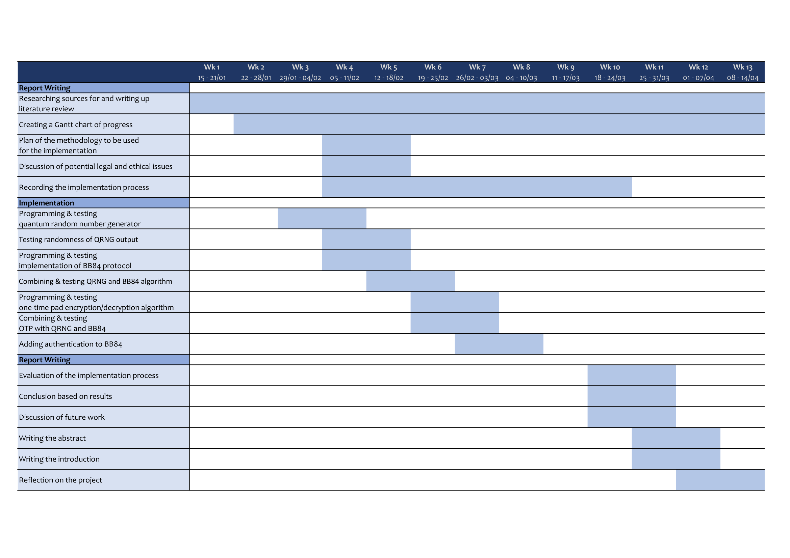

Figure 18

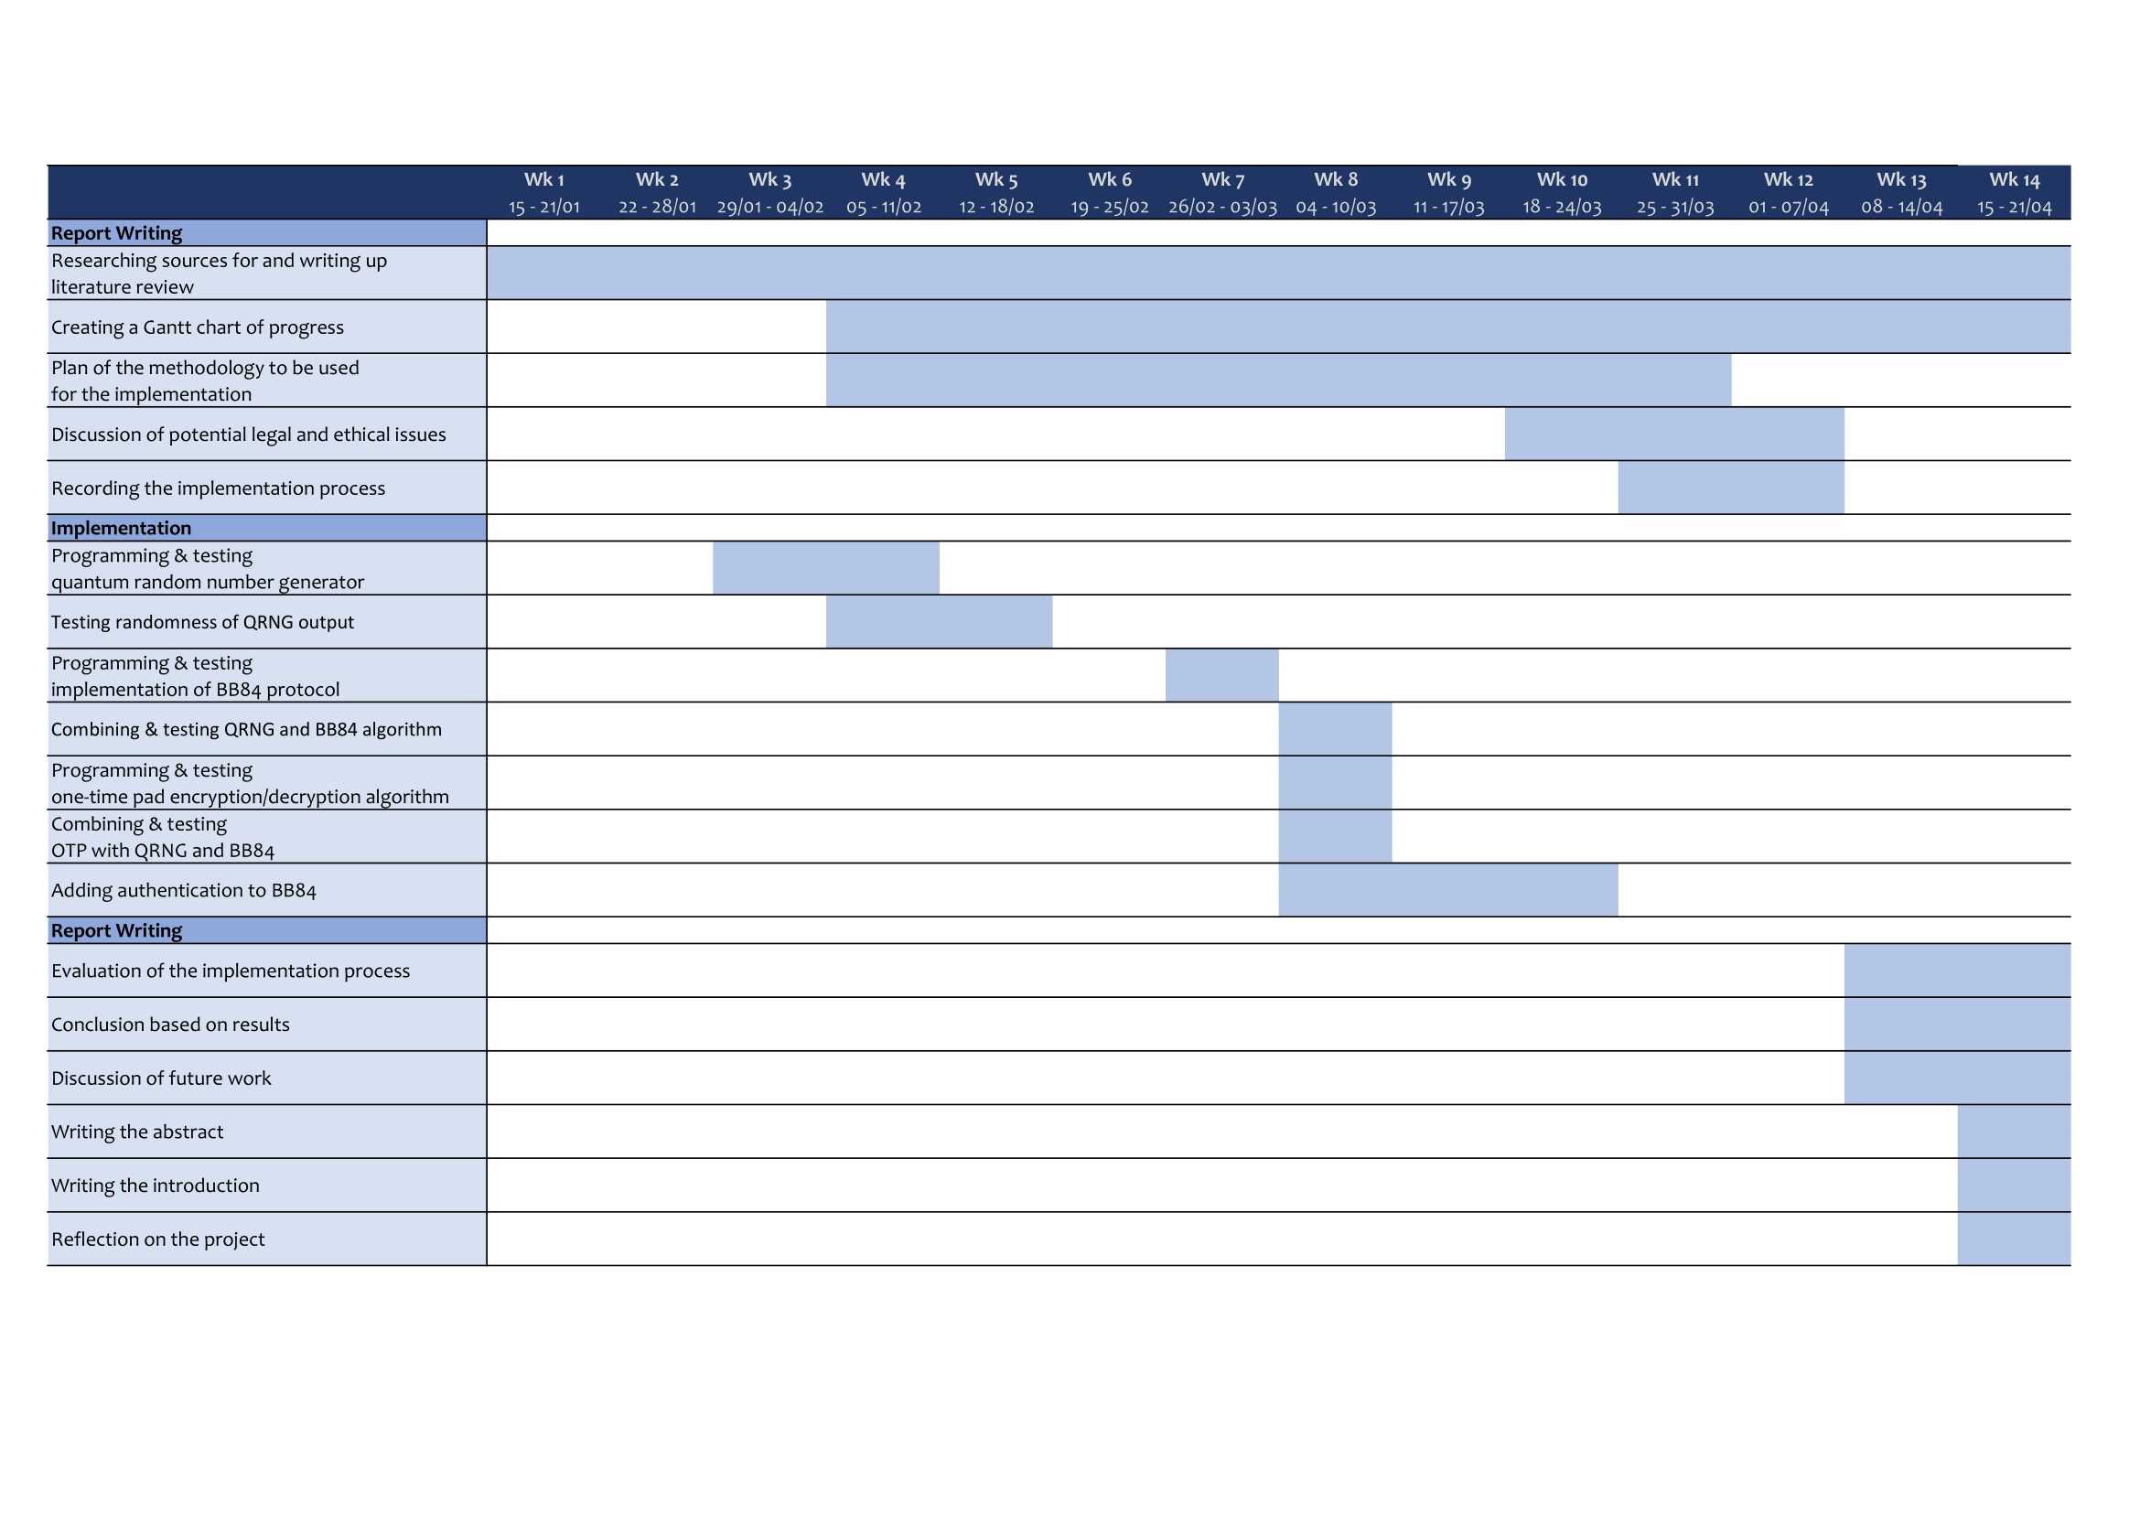

Figure 19

## Reflection on the supervision process

Although I was only able to meet with my supervisor once over the course of the project, the meeting was very helpful in providing some clarification on the report writing process, and answering some questions I had regarding a few different areas of the project. It was also good to be able to explain my ideas and receive an opinion from someone familiar with the field, as quantum cryptography can be a fairly niche subject, and it can be difficult to explain to those that don’t have as much knowledge of the area.

Additionally to this meeting, I was also able to communicate with my supervisor via online messaging on Microsoft Teams throughout the project. This was particularly helpful near the beginning of the timeline when trying to fine-tune my topic idea, as my supervisor was able to provide some thoughts about areas that might be good to consider, like how the developed cryptographic system could be extended to provide authentication.

If I were to repeat this project, I would like to have more communication with my supervisor towards the end of the project, so that I could receive more feedback on the report as I was writing it, and would be able to take any criticisms into consideration to help improve the quality of the report, as well as have any mistakes pointed out so that they could be corrected.

However, overall, I believe I was able to complete the project well with the level of supervision that I had, and I am proud of how I was able to keep myself on track without needing someone to be checking in with to ensure that the work was completed, since, as previously mentioned, organisation and time management are areas that I have struggled with in the past.

# **References**

Amico, M., Saleem, Z., & Kumph, M. (2019, May 14). *An Experimental Study of Shor's Factoring Algorithm on IBM Q*. Physical Review A. <https://arxiv.org/pdf/1903.00768.pdf>

Bennett, C.H., & Brassard, G. (1984, December). *Quantum cryptography: Public key distribution and coin tossing*. Proceedings of IEEE International Conference on Computers, Systems and Signal Processing (pp. 175–179). <https://arxiv.org/ftp/arxiv/papers/2003/2003.06557.pdf>

Diffie, W., & Hellman, M. E. (1976, November). *New directions in cryptography*. IEEE Transactions on Information Theory, vol. 22, no. 6 (pp. 644–654). <https://ee.stanford.edu/%7Ehellman/publications/24.pdf>

Herrero-Collantes, M., & Garcia-Escartin, J. C. (2016, October 24). Quantum Random Number Generators. Reviews of Modern Physics, vol. 89, no. 1. <https://arxiv.org/pdf/1604.03304.pdf>

Hunter, J. D. (2007). *Matplotlib: A 2D graphics environment*. Computing in Science & Engineering, vol. 9, no. 3 (pp. 90–95). <https://matplotlib.org/>

IBM Quantum. (n.d.). *Qiskit*. <https://www.ibm.com/quantum/qiskit>

IPython Development Team. (2024, March 31). *Module: display*. IPython. <https://ipython.readthedocs.io/en/stable/api/generated/IPython.display.html>

Jacak, M. M., Jóźwiak, P., Niemczuk, J., & Jacak, J. E. (2021, August 9). *Quantum generators of random numbers*. Scientific Reports, vol. 11. <https://www.nature.com/articles/s41598-021-95388-7>

Li, Y., Ng, K.S., & Purcell, M. (2022, September 29). *A Tutorial Introduction to Lattice-based Cryptography and Homomorphic Encryption*. <https://arxiv.org/pdf/2208.08125.pdf>

Martin-Lopez, E., Laing, A., Lawson, T., Alvarez, R., Zhou, X., & O'Brien, J. L. (2012, October 21). *Experimental realization of Shor's quantum factoring algorithm using qubit recycling*. Nature Photonics, vol. 6, no. 11 (pp. 773–776). <https://arxiv.org/pdf/1111.4147.pdf>

Moschandreou, E., Rollick, B. J., Qi, B., & Siopsis, G. (2021, March 26). *Experimental decoy state BB84 quantum key distribution through a turbulent channel*. Physical Review A, vol. 103, no. 3. <https://arxiv.org/pdf/2012.04498.pdf>

Nielsen, M. A., & Chuang. I. L. (2012, June 1). *Quantum Computation And Quantum Information 10th Anniversary Edition*. Cambridge University Press. <http://almuhammadi.com/sultan/books_2020/Nielsen_Chuang.pdf>

NIST. (2022, July 5). *NIST Announces First Four Quantum-Resistant Cryptographic Algorithms*. <https://www.nist.gov/news-events/news/2022/07/nist-announces-first-four-quantum-resistant-cryptographic-algorithms>

Python documentation. (2024, April 16). *math — Mathematical functions*. <https://docs.python.org/3/library/math.html>

Rivest, R. L., Shamir, A., & Adleman, L. (1978, February). *A Method for Obtaining Digital Signatures and Public-Key Cryptosystems*. Communications of the ACM, vol. 21, no. 2 (pp. 120–126). <https://people.csail.mit.edu/rivest/Rsapaper.pdf>

Rukhin, A., Soto, J., Nechvatal, J., Smid, M., Barker, E., Leigh, S., Levenson, M., Vangel, M., Banks, D., Heckert, A., Dray, J., Vo, S., & Bassham, L. (2010, April). *A Statistical Test Suite for Random and Pseudorandom Number Generators for Cryptographic Applications*. NIST. <https://csrc.nist.gov/Projects/Random-Bit-Generation/Documentation-and-Software>

Sasaki, M., Fujiwara, M., Ishizuka, H., Klaus, W., Wakui, K., Takeoka, M., Miki, S., Yamashita, T., Wang, Z., Tanaka, A., Yoshino, K., Nambu, Y., Takahashi, S., Tajima, A., Tomita, A., Domeki, T., Hasegawa, T., Sakai, Y., Kobayashi, H., Asai, T., Shimizu, K., Tokura, T., Tsurumaru, T., Matsui, M., Honjo, T., Tamaki, K., Takesue, H., Tokura, Y., Dynes, J.F., Dixon, A.R., Sharpe, A.W., Yuan, Z.L., Shields, A.J., Uchikoga, S., Legre, M., Robyr, S., Trinkler, P., Monat, L., Page, J., Ribordy, G., Poppe, A., Allacher, A., Maurhart, O., Länger, T., Peev, M., & Zeilinger, A. (2011). *Field test of quantum key distribution in the Tokyo QKD Network*. Optics Express, vol. 19, no. 11 (pp. 10387–10409). <https://arxiv.org/ftp/arxiv/papers/1103/1103.3566.pdf>

Shannon, C. E. (1949, October). *Communication Theory of Secrecy Systems*. Bell System Technical Journal, vol. 28, no. 4 (pp. 656–715). Nokia Bell Labs. <https://www.cs.virginia.edu/~evans/greatworks/shannon1949.pdf>

Shor, P. W. (1994). *Algorithms for quantum computation: discrete logarithms and factoring*. Proceedings 35th Annual Symposium on Foundations of Computer Science (pp. 124–134). <http://cc.ee.ntu.edu.tw/~rbwu/rapid_content/course/QC/Shor1994.pdf>

Singh, S. (1999). *The Code Book: The secret history of codes and code-breaking*. HarperCollins.